**Aim -**

To study and implement Identity and Access Management (IAM) practices on AWS/Azure cloud.

**Theory -**

Identity as a Service (IDaaS) is a cloud-based service model that provides organizations with identity and access management (IAM) capabilities over the internet. In IDaaS, organizations can manage user identities, authentication, authorization, and access control policies centrally through a cloud-based platform, rather than deploying and managing IAM infrastructure on-premises.

Advantages of Identity as a Service (IDaaS):

* Centralized Identity Management: IDaaS enables organizations to centrally manage user identities, access controls, and authentication mechanisms across multiple applications and services. This centralization simplifies identity management tasks and improves administrative efficiency.
* Scalability: IDaaS platforms offer scalability features that allow organizations to easily scale their identity management infrastructure up or down based on changing requirements. This elasticity enables organizations to accommodate growing user populations and expanding application portfolios without the need for manual intervention.
* Cost Efficiency: IDaaS follows a pay-as-you-go pricing model, where organizations only pay for the identity management services and resources they consume. This eliminates the need for upfront investment in IAM infrastructure, reducing capital expenditure and enabling cost-effective scaling based on demand.
* Improved Security: Many IDaaS providers offer advanced security features, such as multi-factor authentication (MFA), single sign-on (SSO), identity federation, and risk-based authentication, to enhance security posture and protect against unauthorized access and data breaches.
* Enhanced User Experience: IDaaS platforms provide seamless and consistent authentication and access experiences for users across multiple applications and devices. Features such as single sign-on (SSO) and self-service password reset improve user convenience and productivity while reducing helpdesk support overhead.

Disadvantages of Identity as a Service (IDaaS):

* Data Privacy and Compliance Concerns: Storing and managing user identities and access control policies in a third-party cloud environment may raise concerns about data privacy and compliance with regulatory requirements, such as GDPR or HIPAA. Organizations must carefully evaluate the data privacy and compliance measures implemented by IDaaS providers to ensure compliance with relevant regulations.
* Dependency on Internet Connectivity: IDaaS relies on internet connectivity for accessing and managing identity management services, which may pose challenges in environments with limited or unreliable internet connectivity. Organizations should consider the potential impact of internet outages or disruptions on their identity management operations.
* Vendor Lock-In: Migrating user identities and access controls between different IDaaS providers or transitioning from IDaaS to an on-premises IAM deployment may be challenging and costly, leading to vendor lock-in. Organizations should consider the long-term implications of vendor lock-in and evaluate strategies to mitigate this risk.
* Customization and Integration Challenges: IDaaS platforms may have limitations in terms of customization and integration with existing IAM systems, directory services, and legacy applications. Organizations with complex identity management requirements may encounter challenges in fully integrating IDaaS solutions into their existing infrastructure.
* Performance and Reliability: Performance and reliability issues may arise in IDaaS environments, particularly in multi-tenant deployments where resources are shared among multiple users. Organizations should assess the performance characteristics and service level agreements (SLAs) of IDaaS offerings to ensure they meet their performance and reliability requirements.

**Procedure-**

Login to AWS console

Make sure to check all Ec2 dashboard parameters

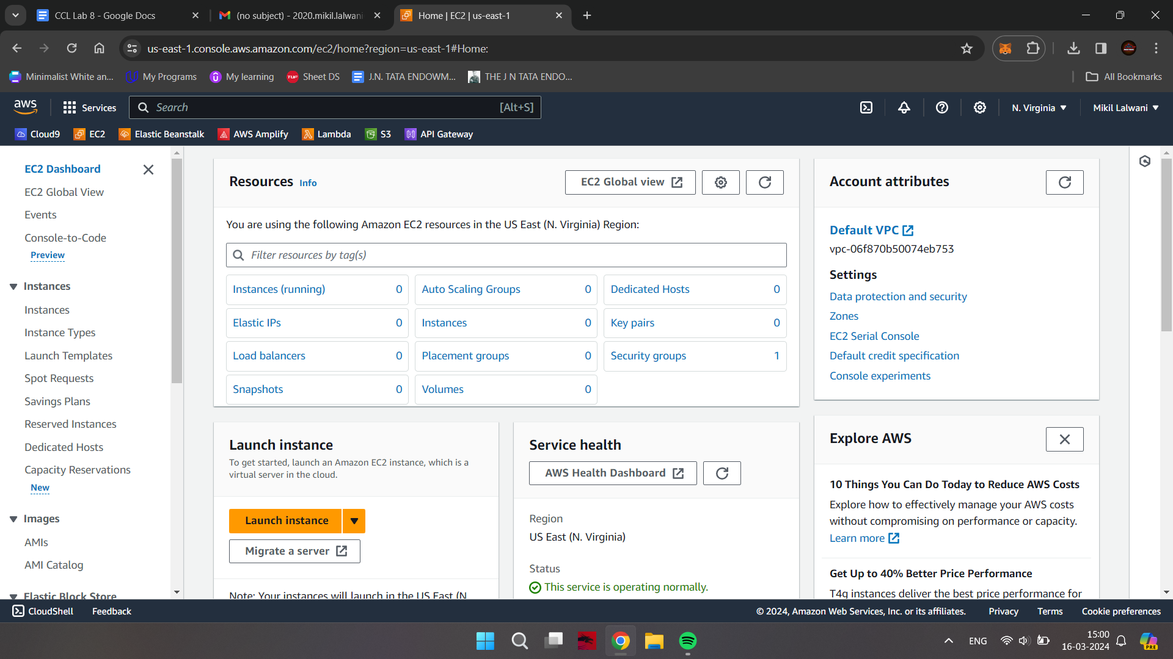

**Configuring IAM Dashboard**

Go to IAM dashboard

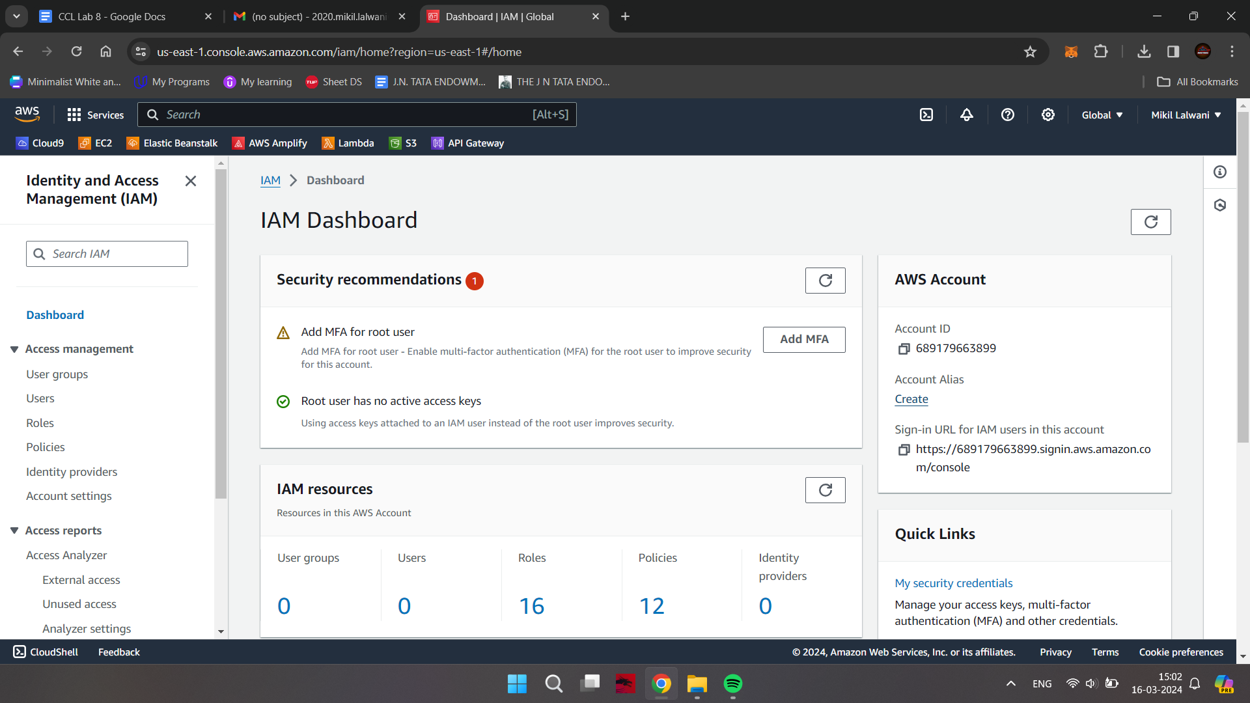

Click on create option under Account Alias and give a valid name; save changes

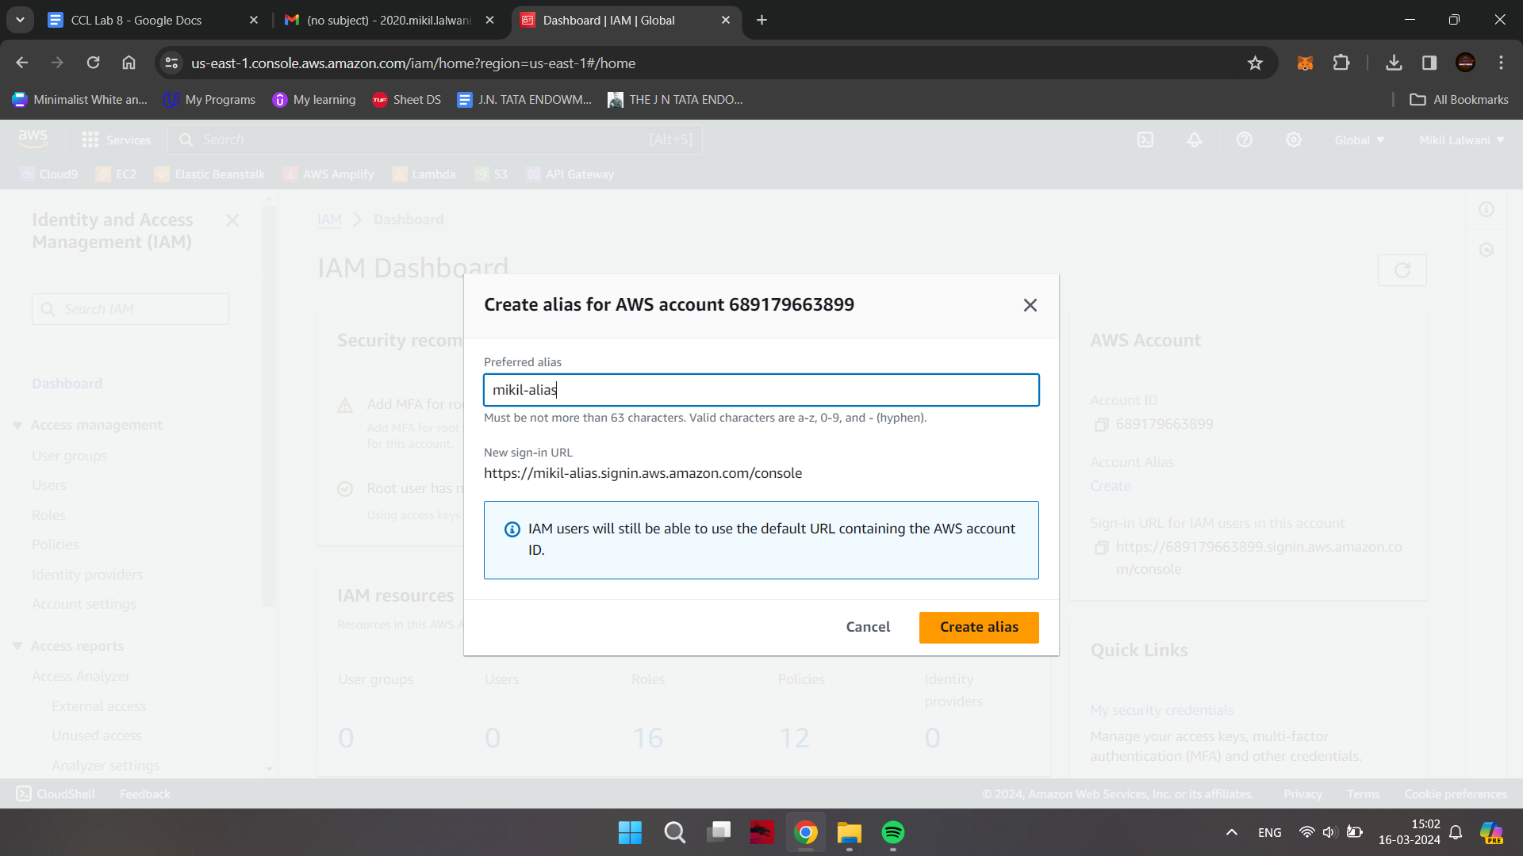

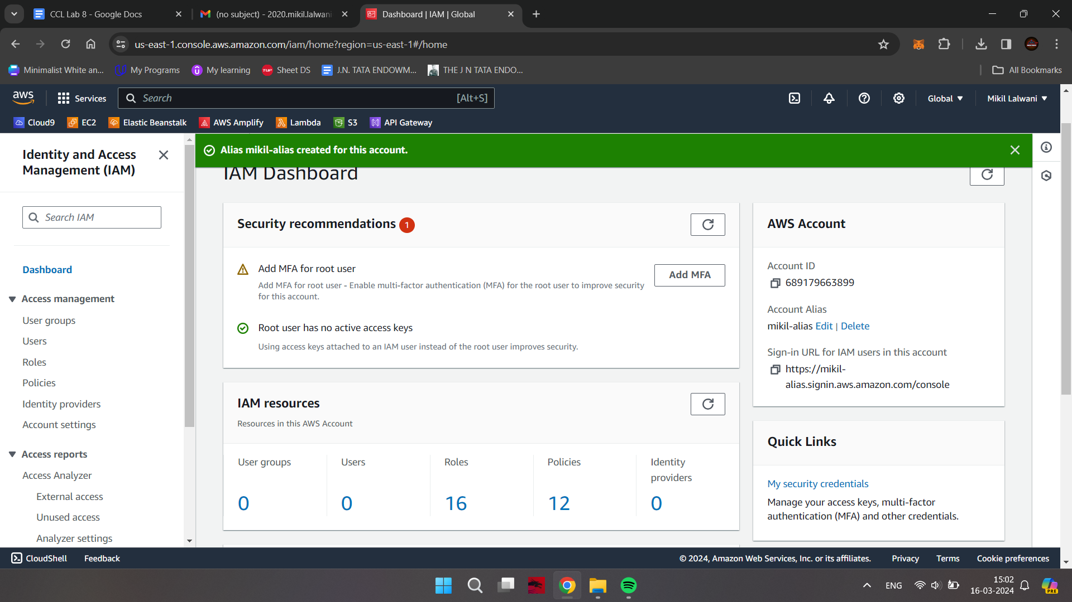

**Creating a new User**

Click on “users” in the left column

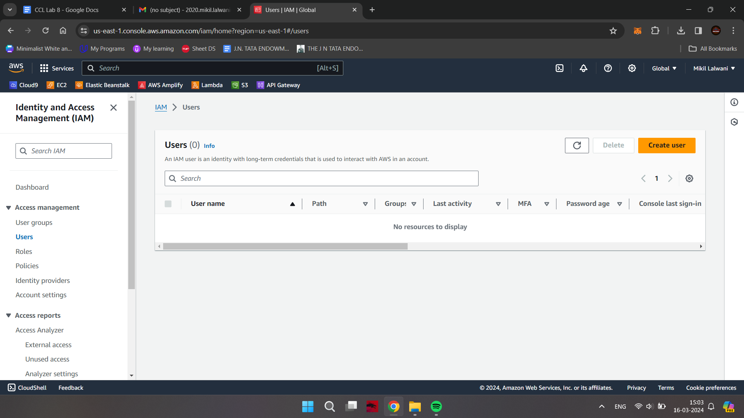

Click on Add users button

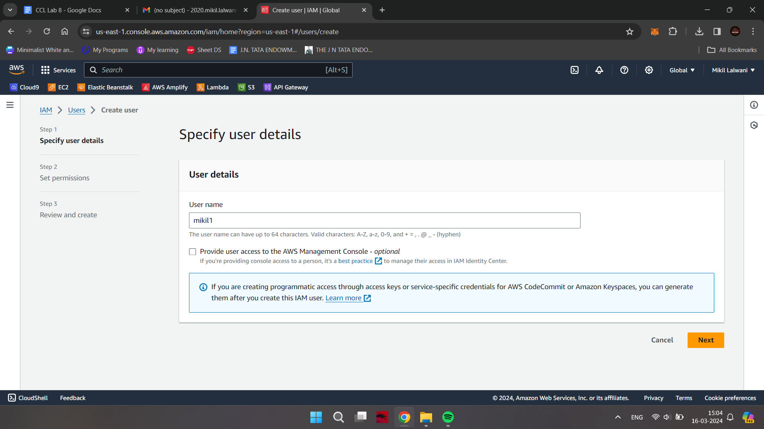

Set a custom valid password (Imc: Qwertyuiop123) and check the Require password reset box which will make you create a next password in the next sign in

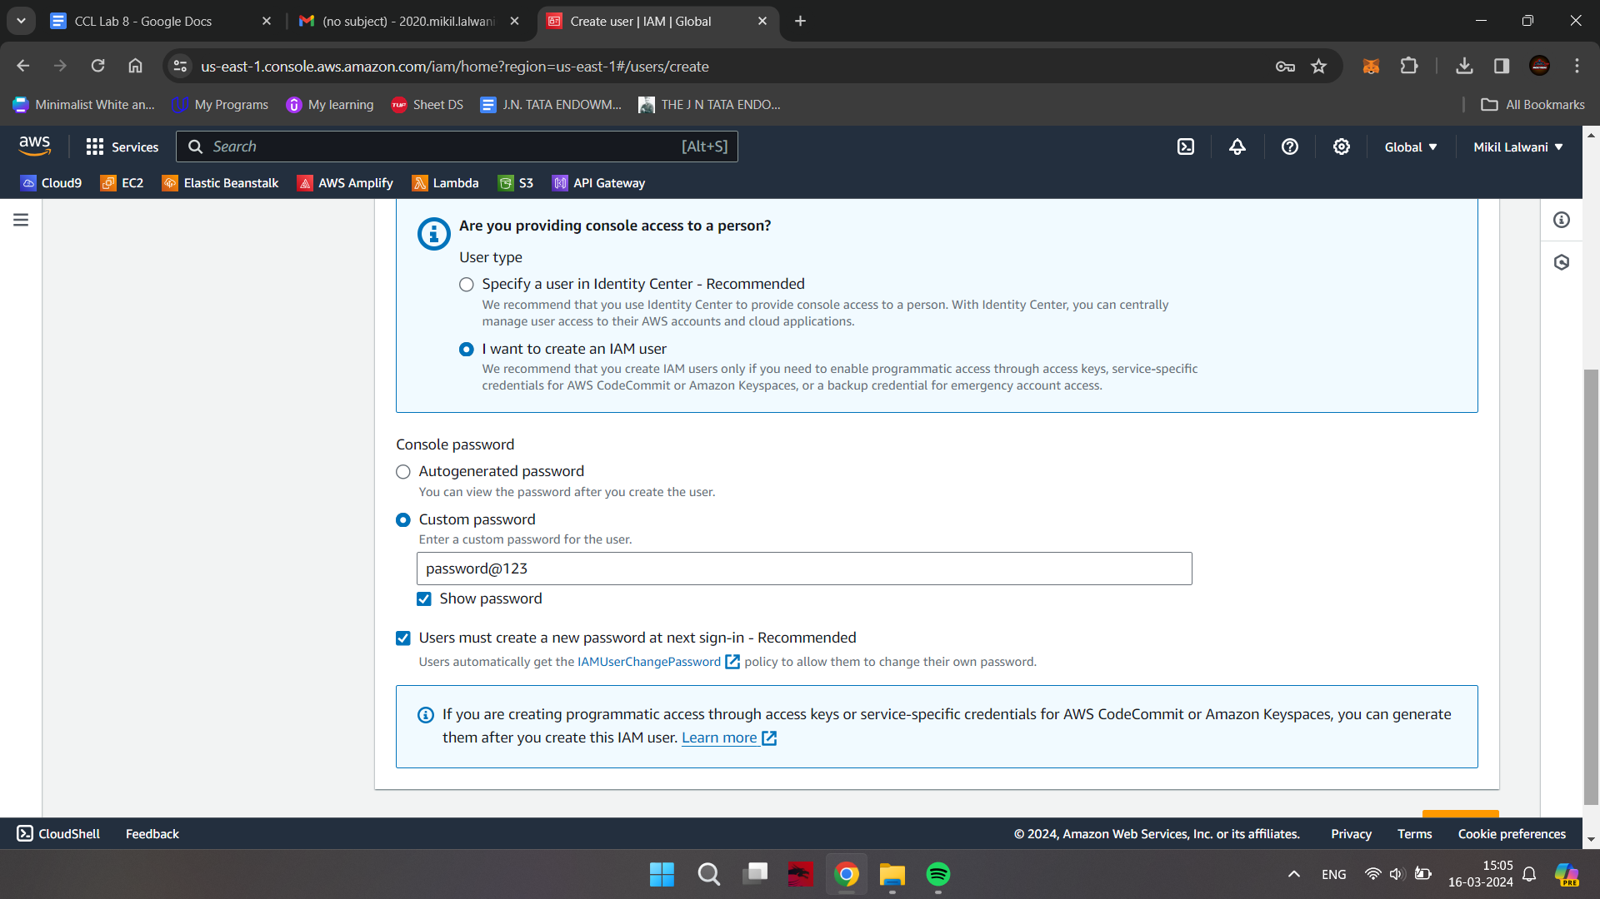

Click on Next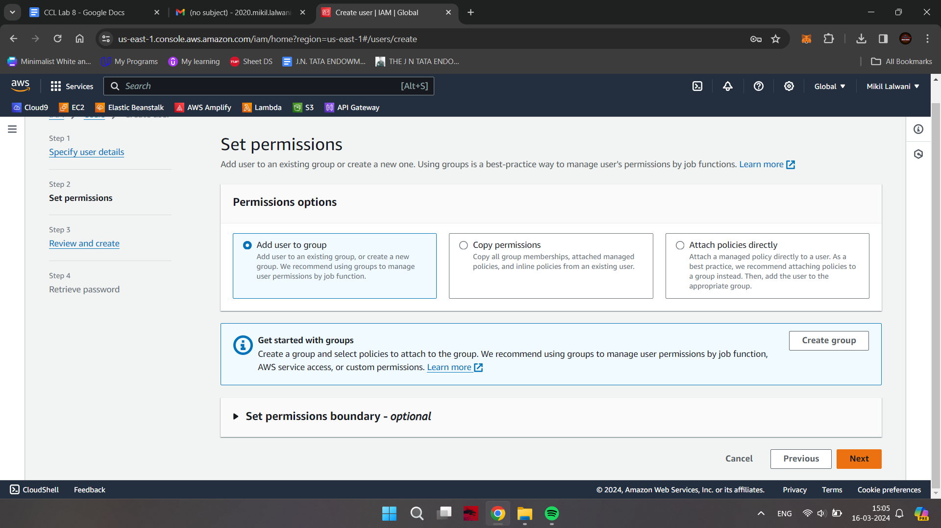

Add a tag if you want to just to keep track of your activities; then click on Next: Review

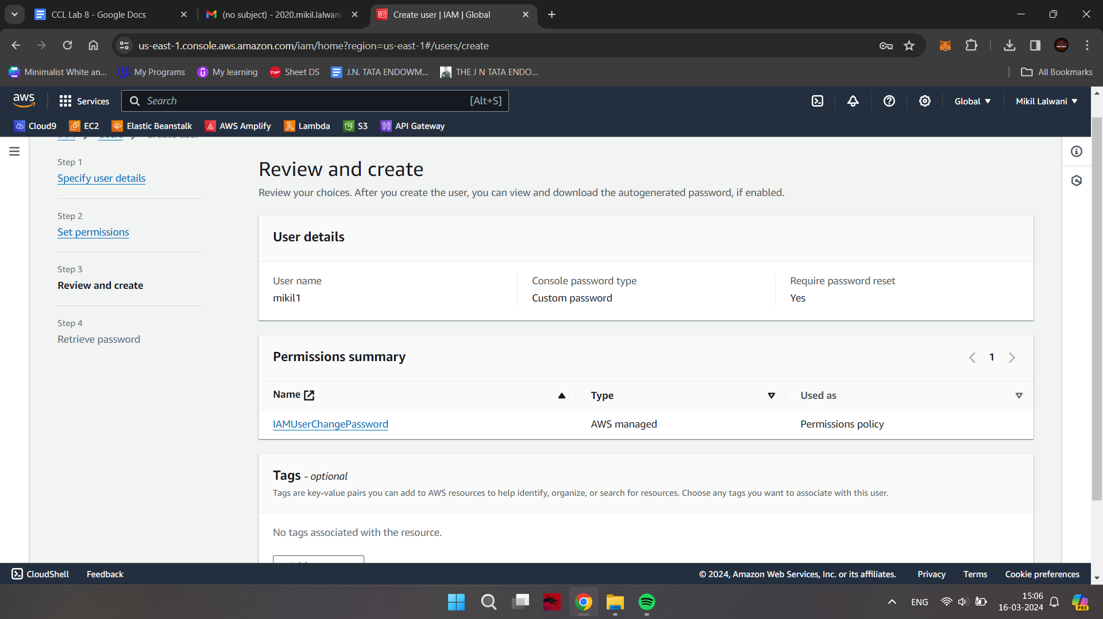

Click on Create User Button

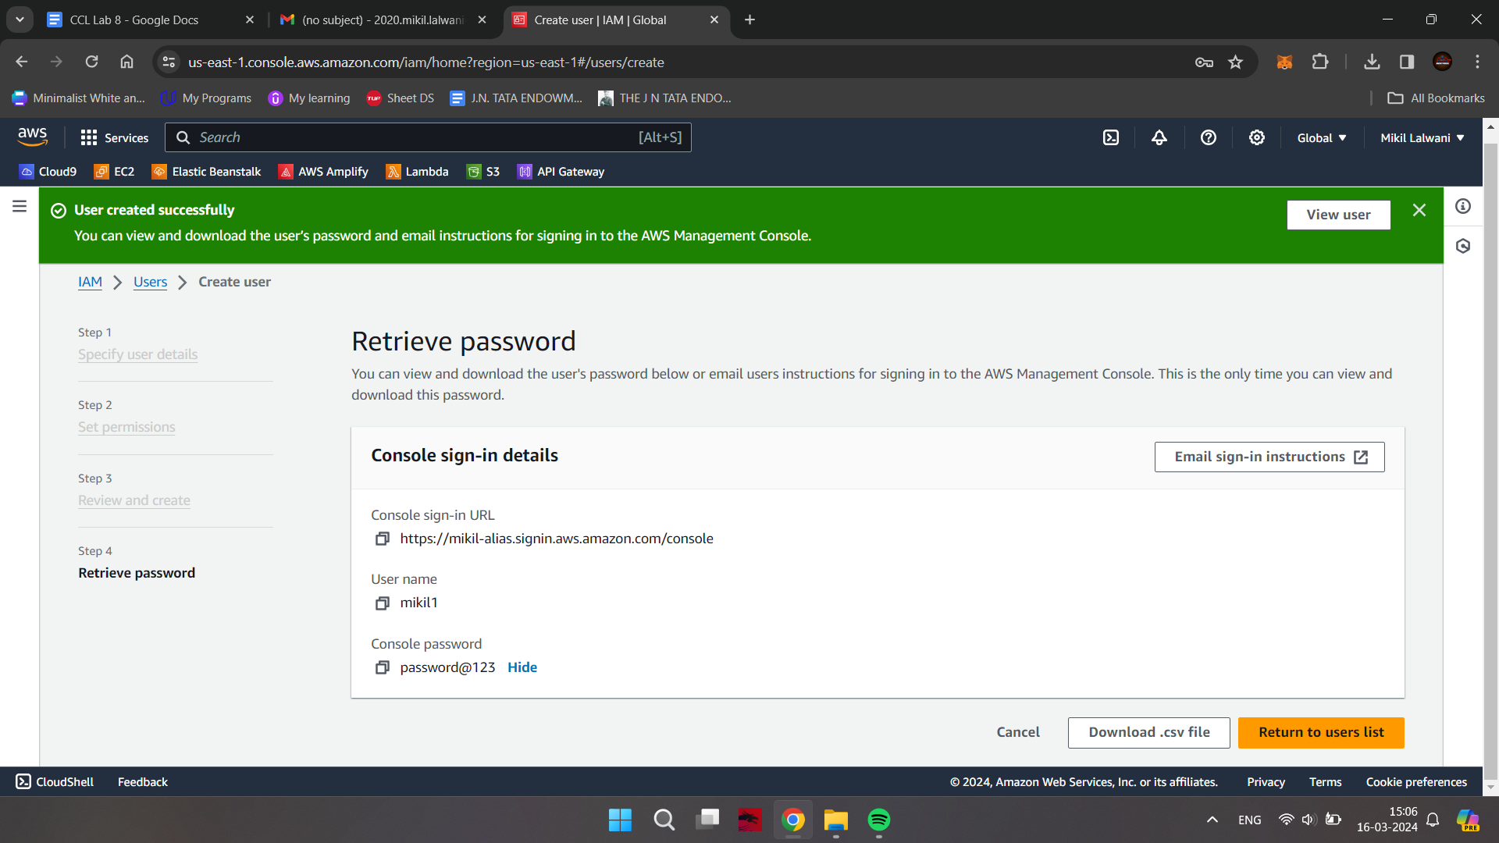

Open the URL in Incognito Mode

**Logging in as the new User & Checking their permissions**

Enter the new user’s name and password saved earlier

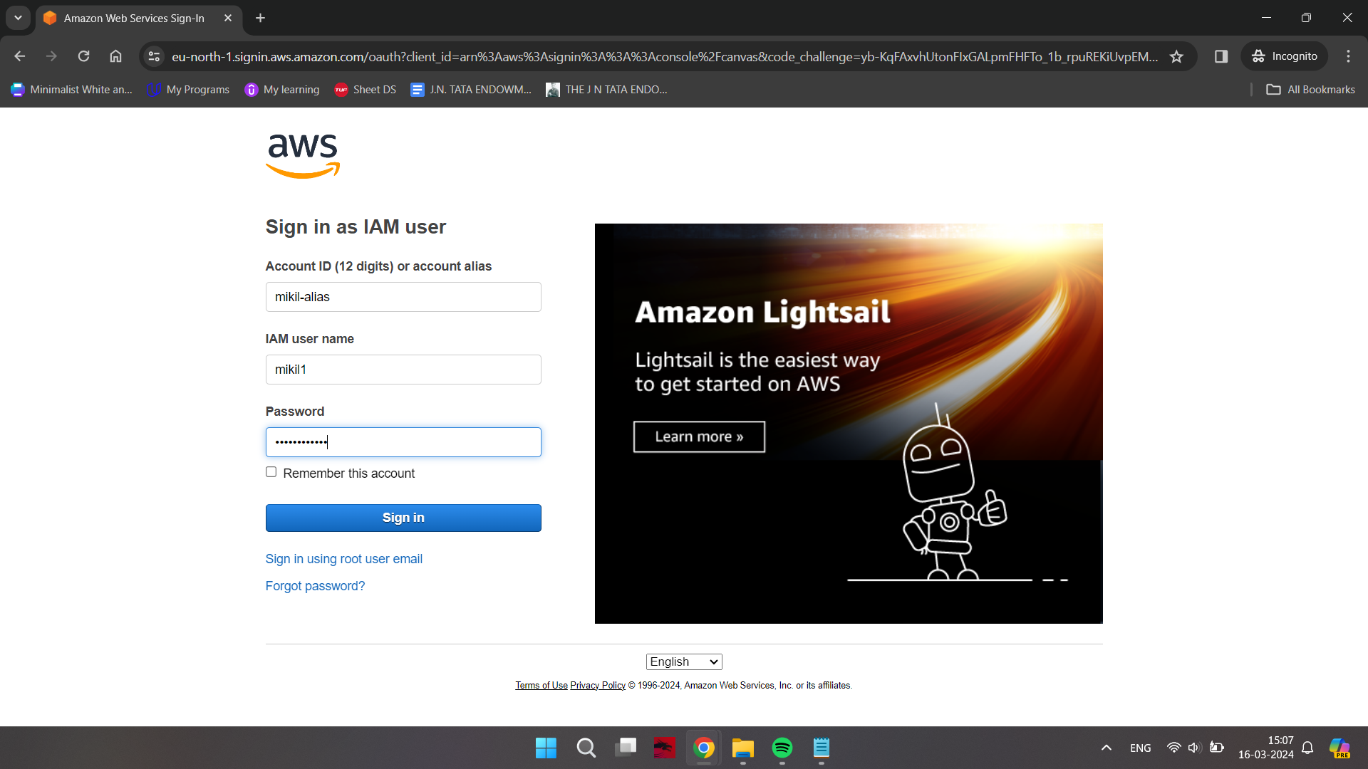

Enter a new valid password

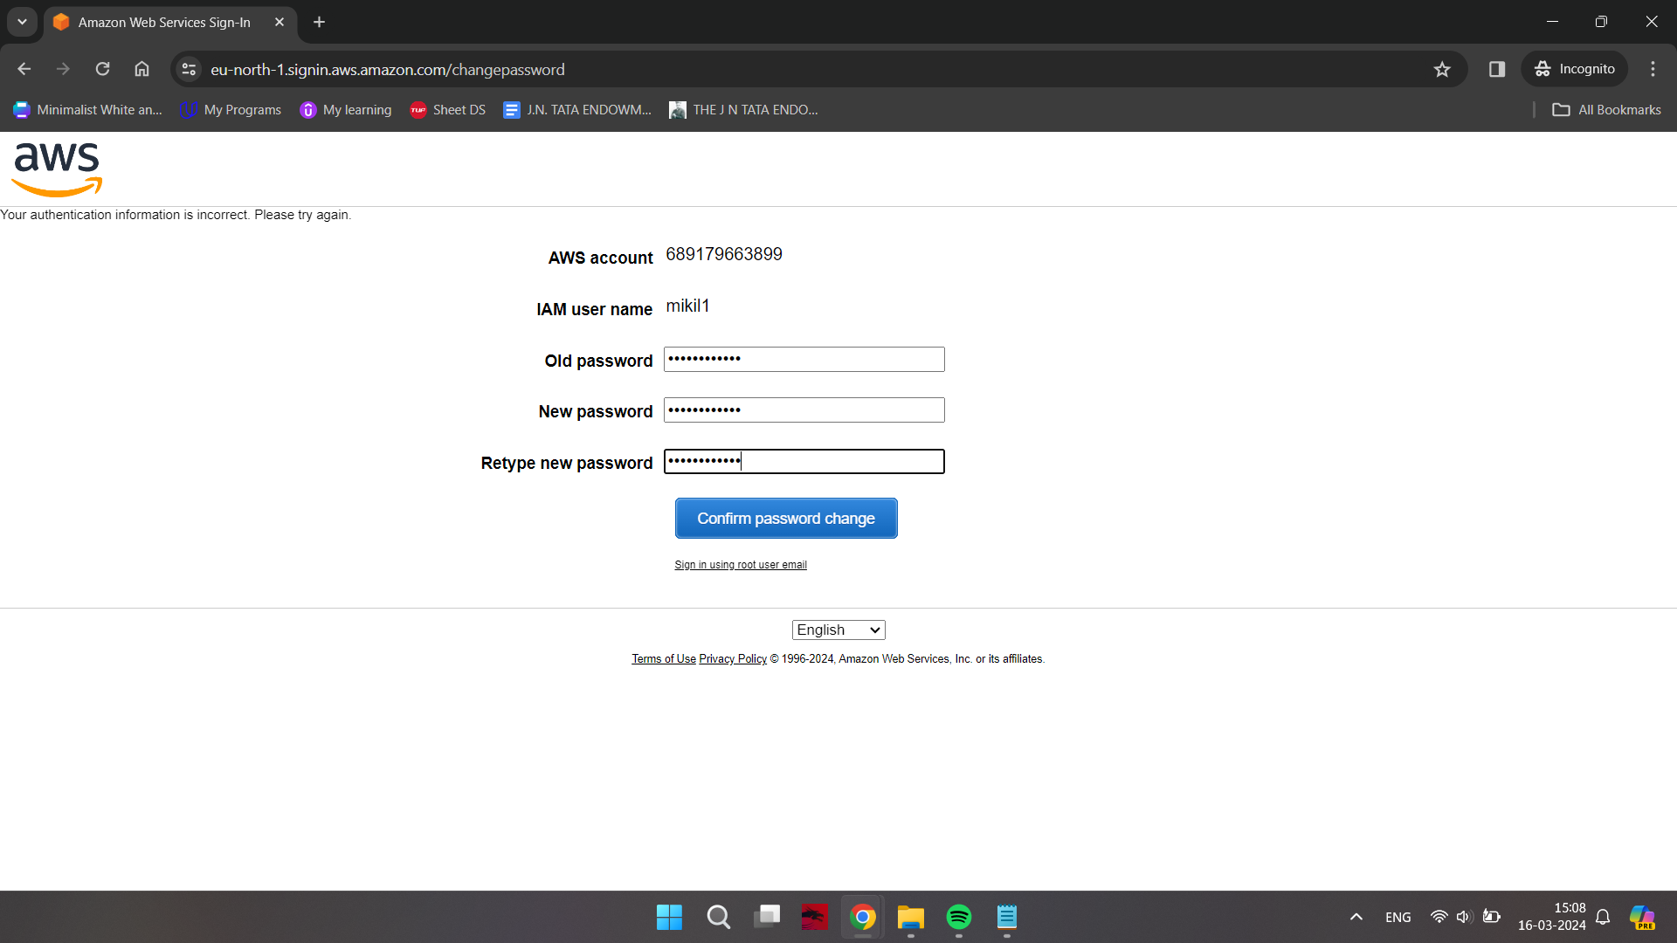

After logging in, you will notice that you don’t have permission to do anything yet

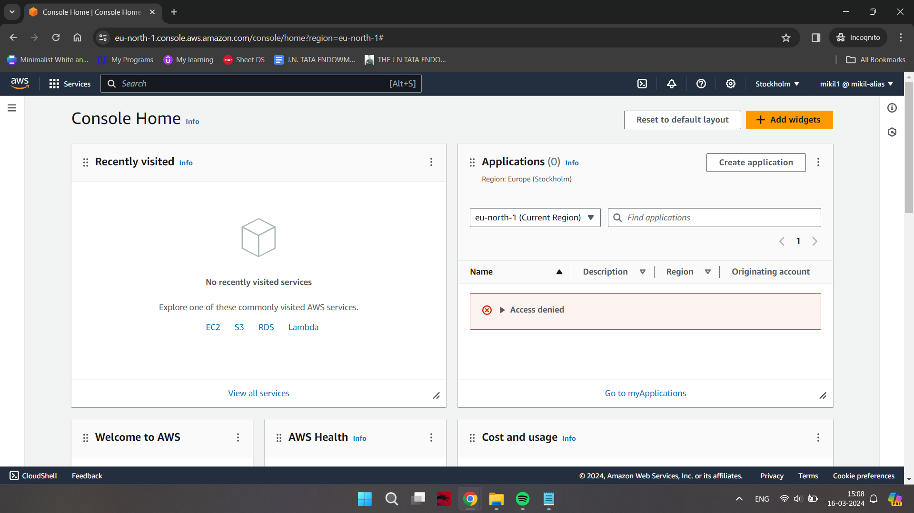

**Adding MFA for the user via Root User**

Type “AWS CLI” in a new window of any browser and go to it’s the main page of AWS

regarding the same.

Click on 64-bit hyperlink in the RHS column under the Windows section and download, install the AWS CLI.

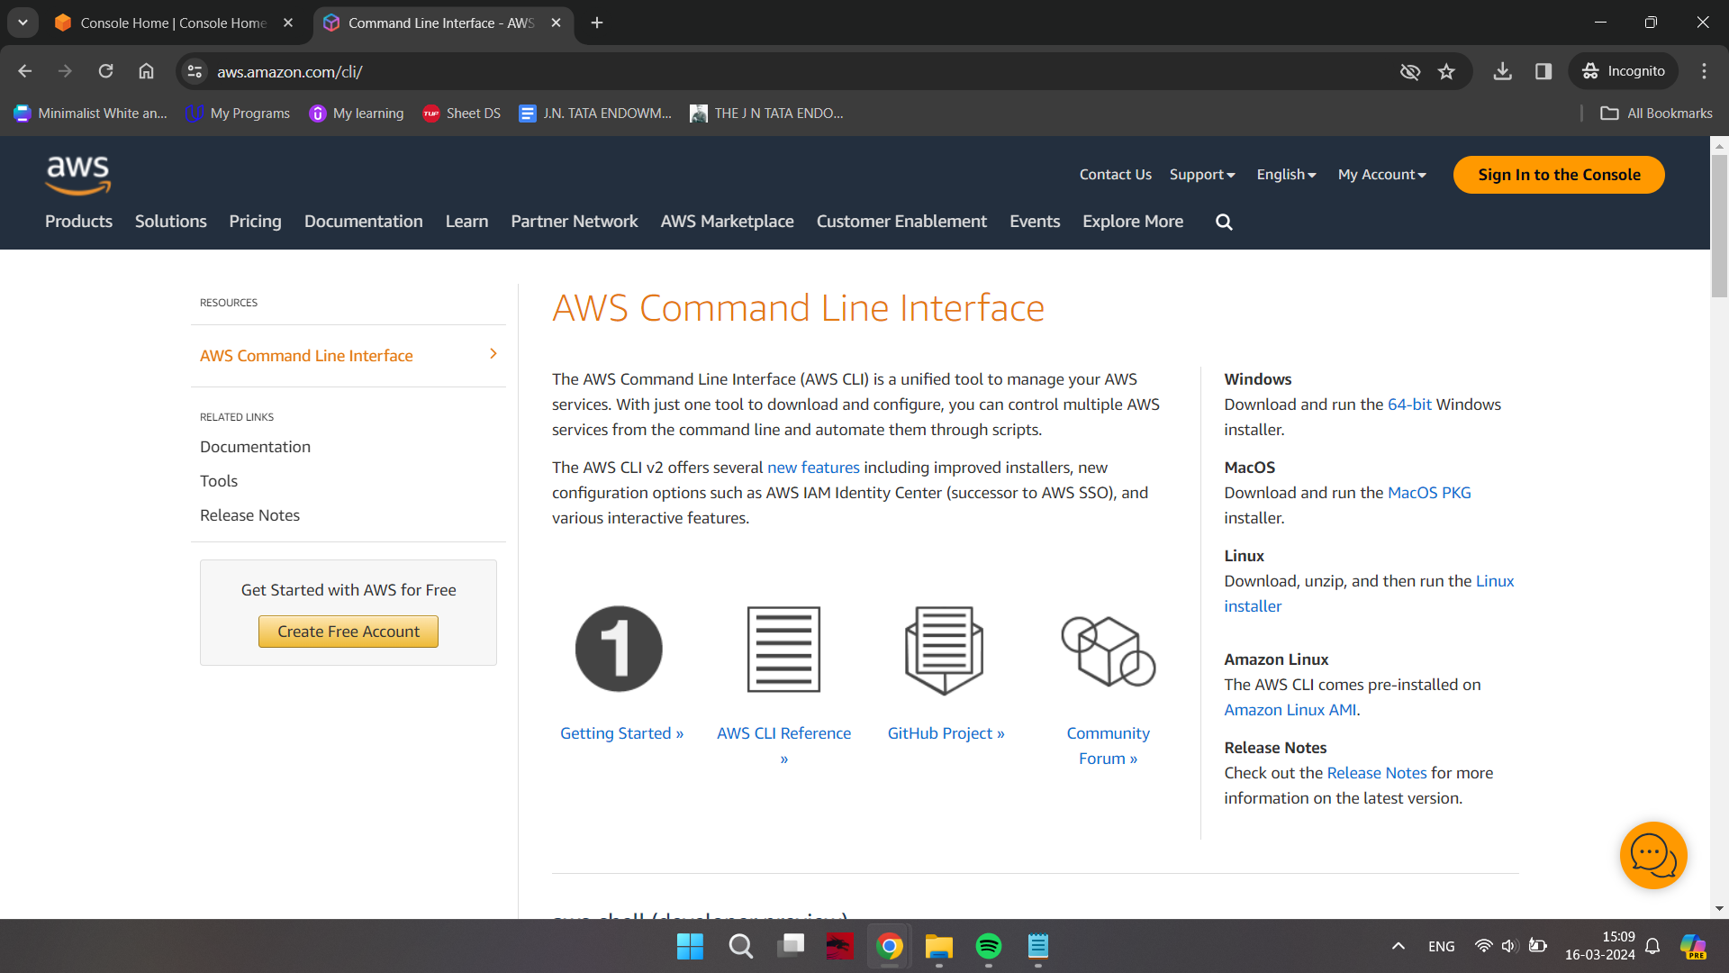

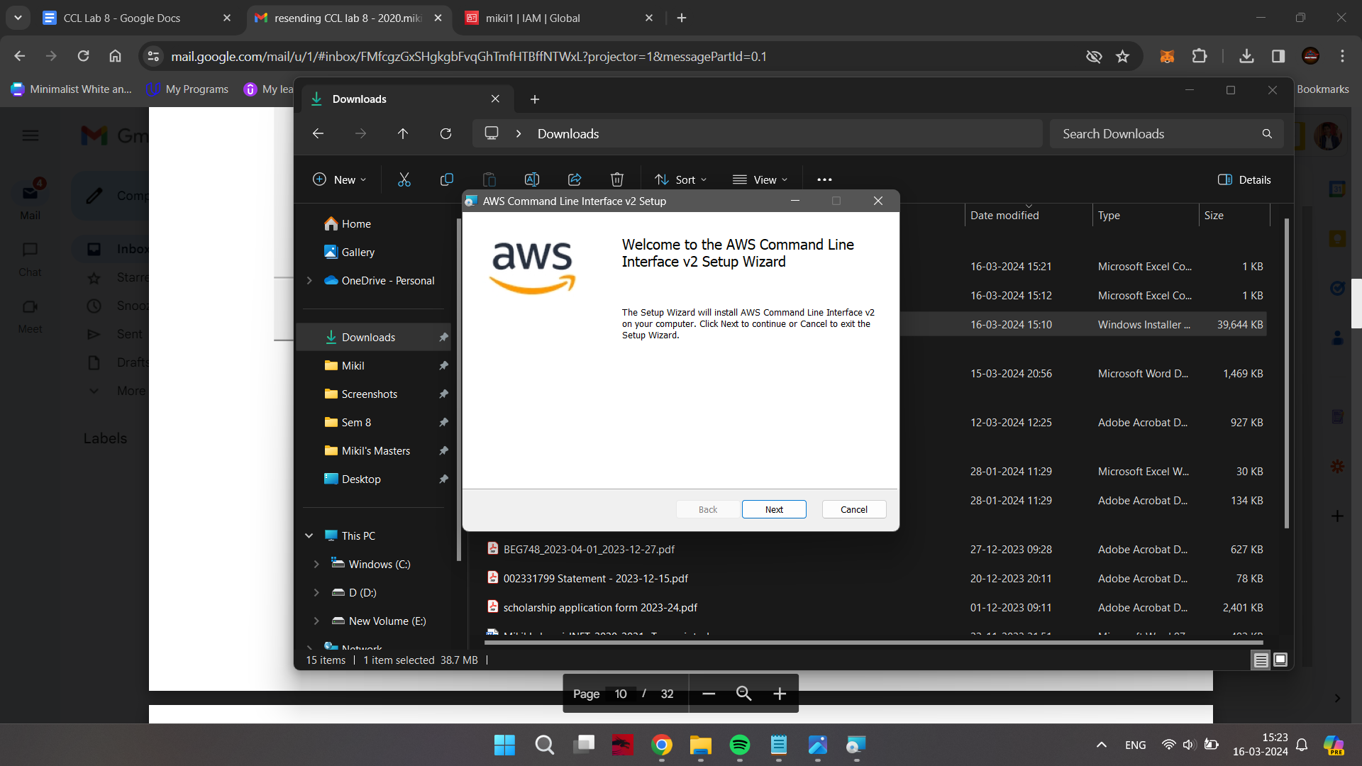

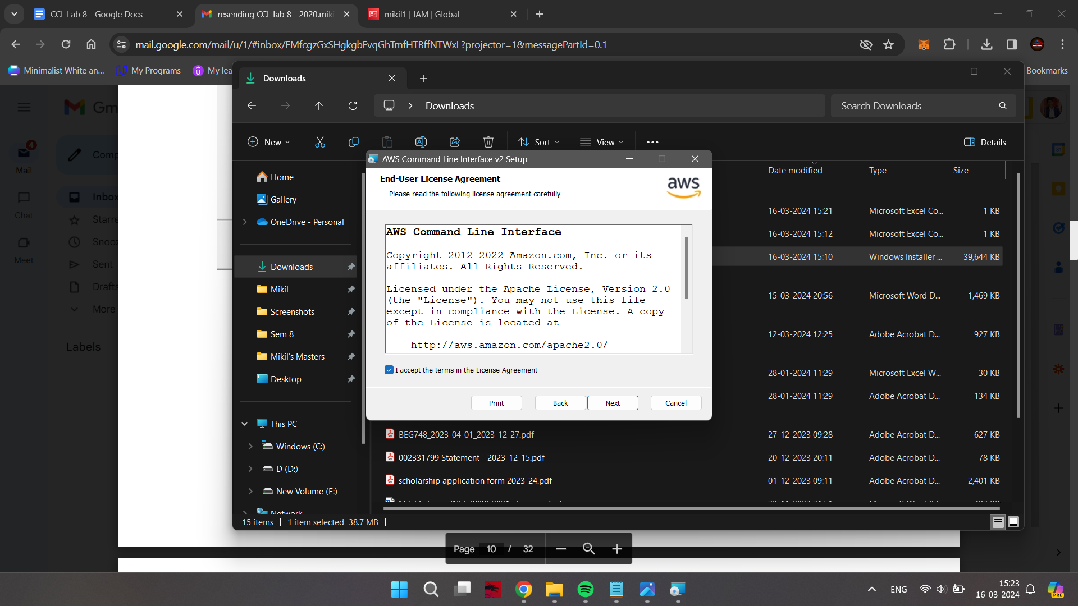

Generate the AccessKeyID and Key needed for AWS CLI.

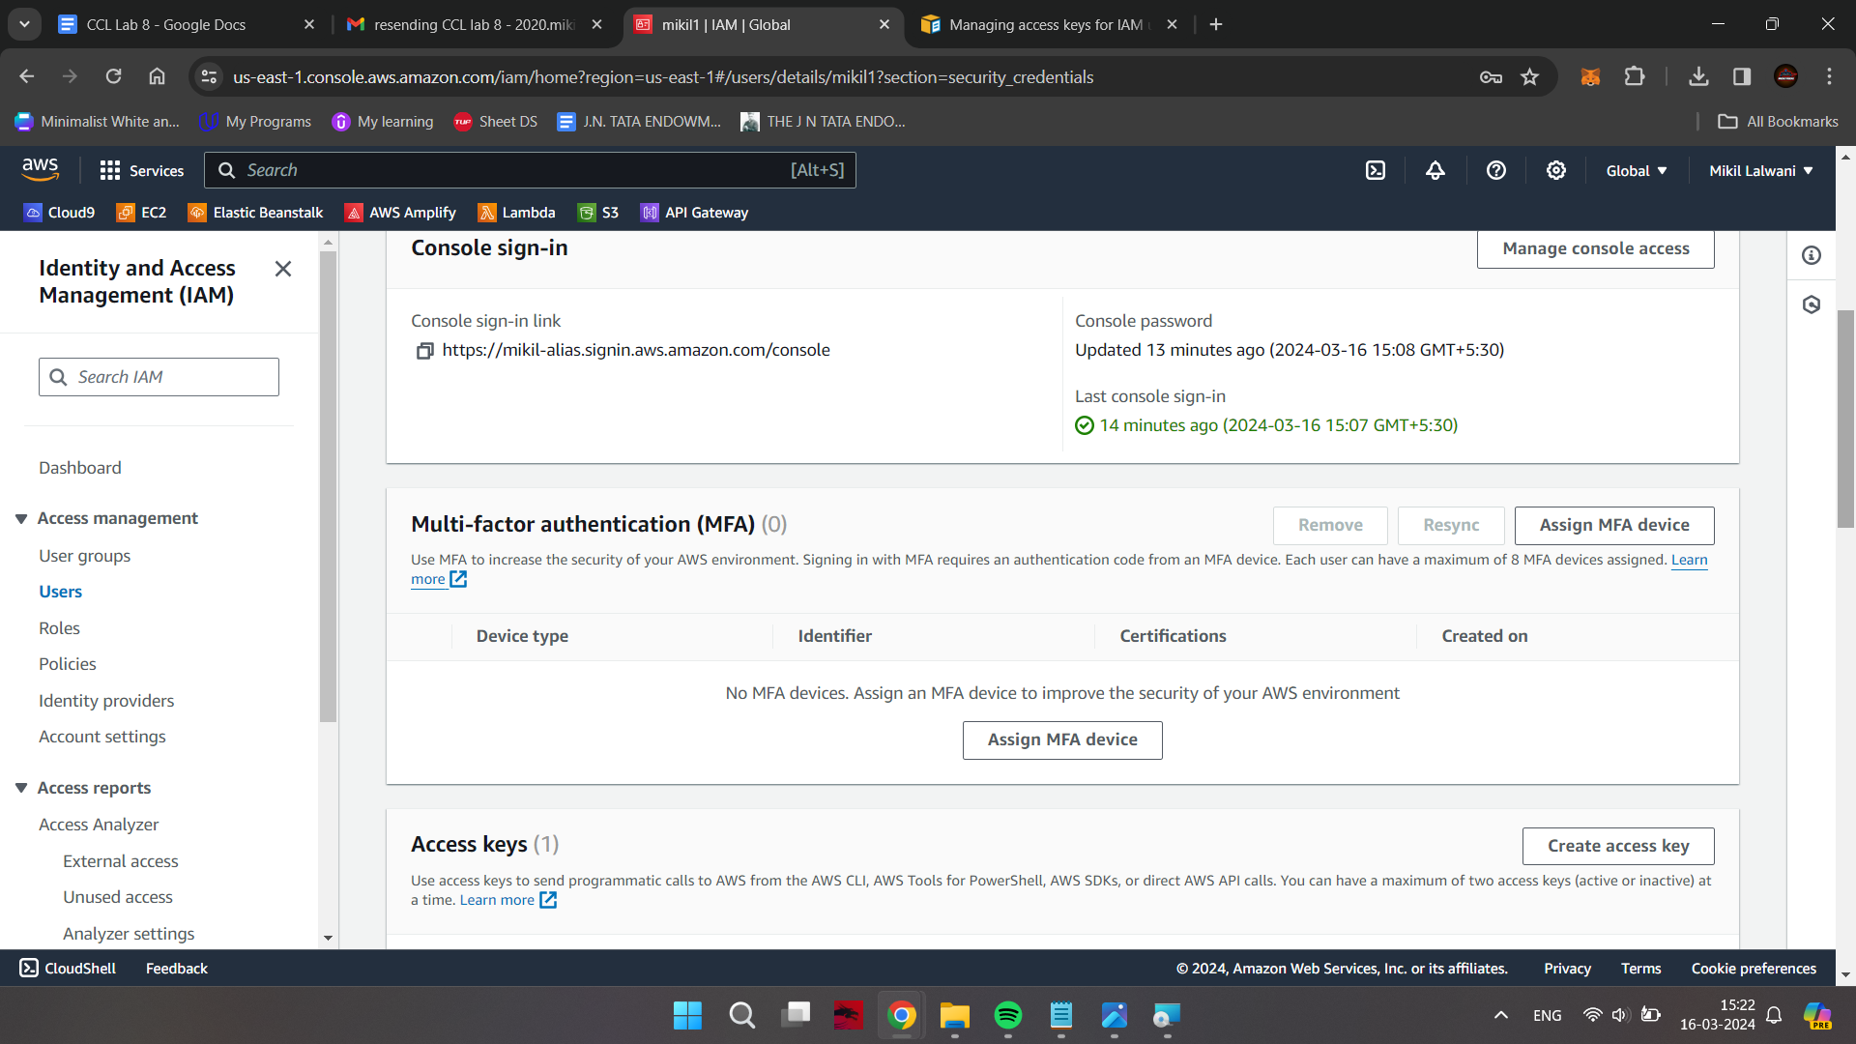

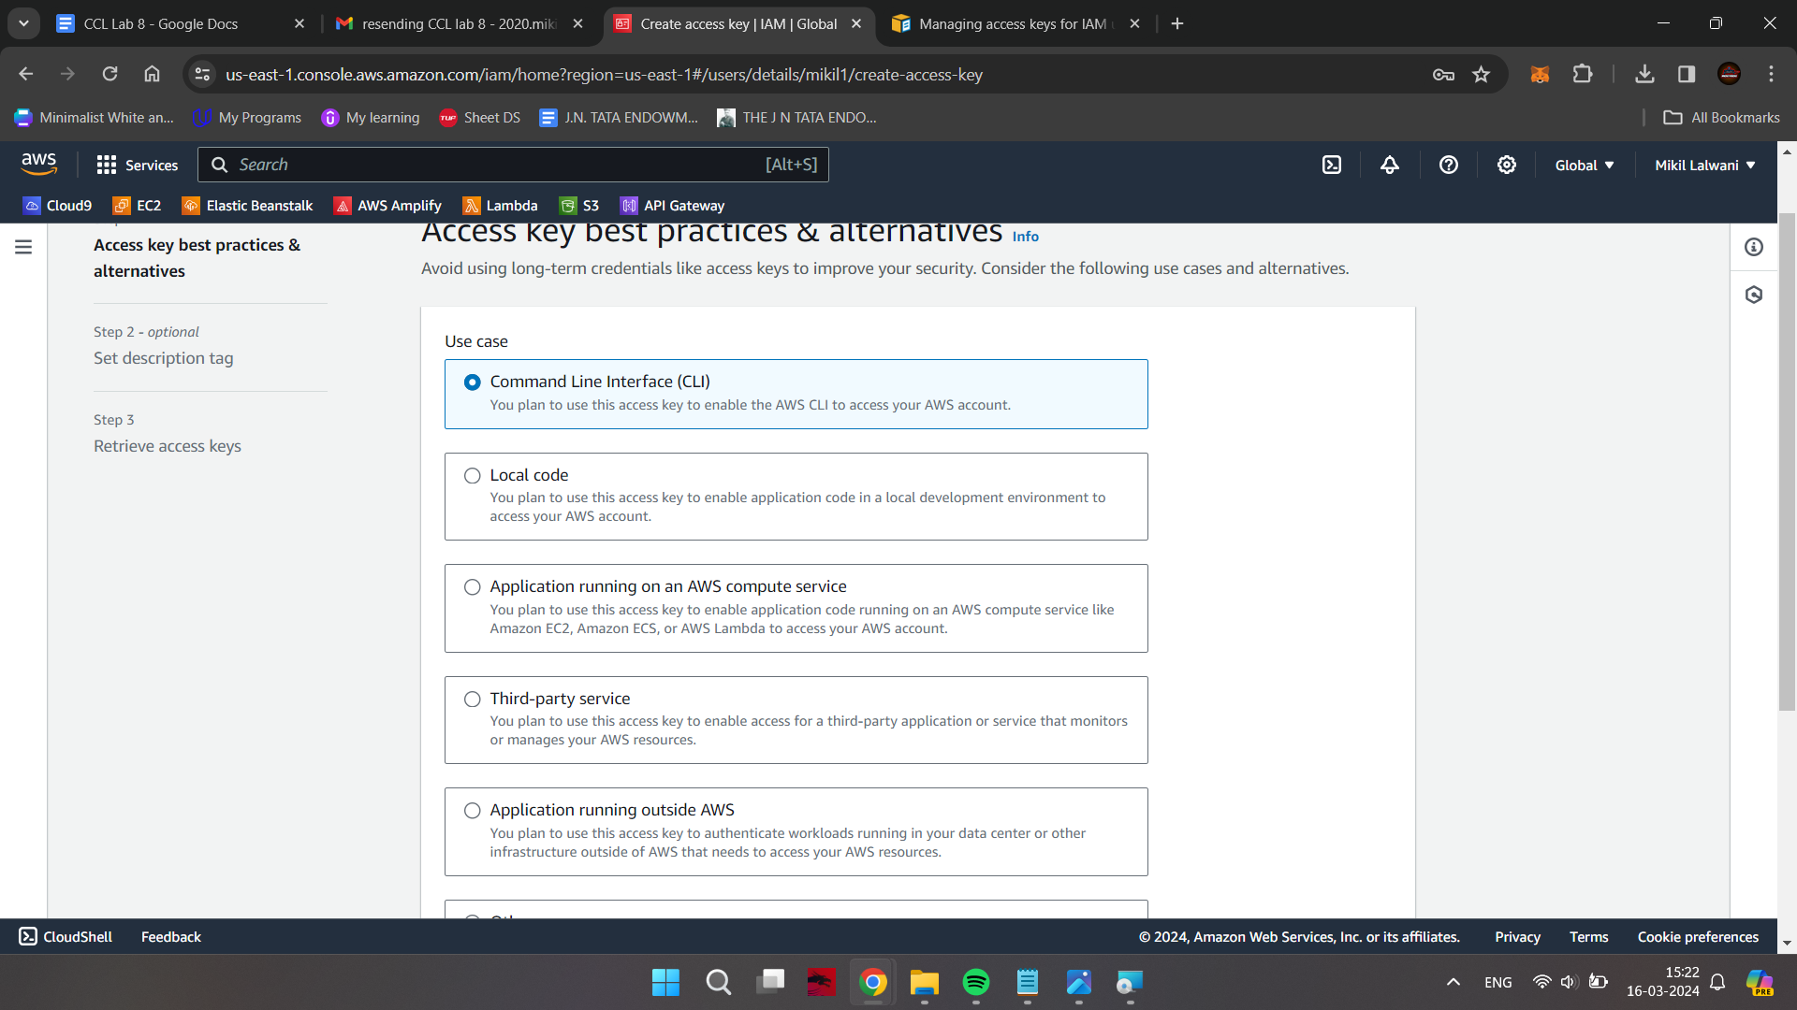

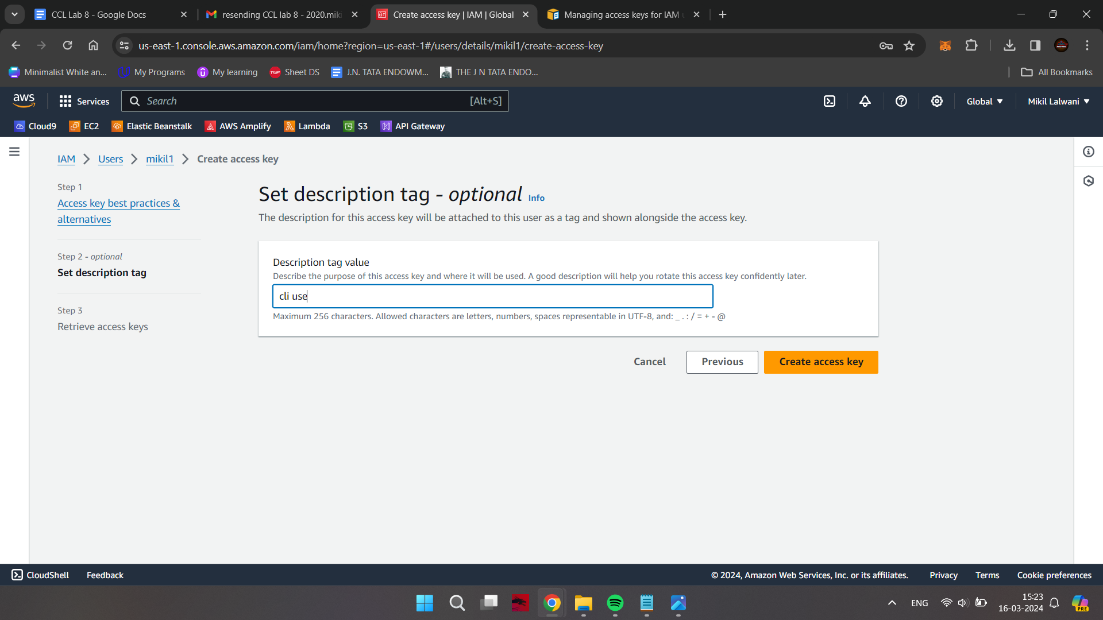

Type “cmd” in the windows search bar and run it as an administrator

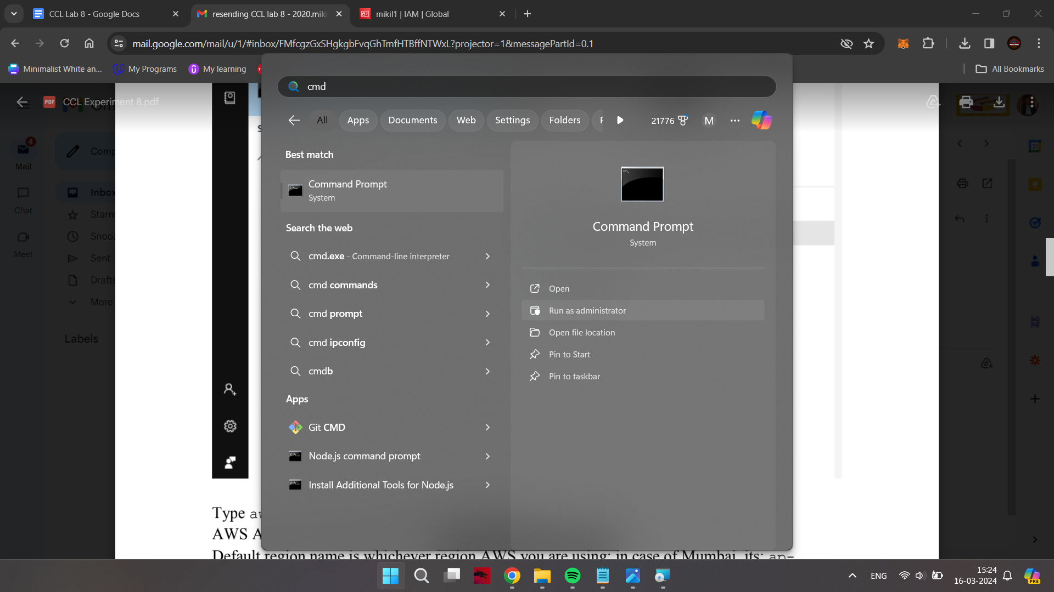

Type aws configure, it will ask for a few inputs;

AWS Access Key ID and Key are the ones which we saved earlier

Default region name is whichever region AWS you are using; in case of Mumbai, its: *ap-*

*south-1*

The output format is *json* in our case

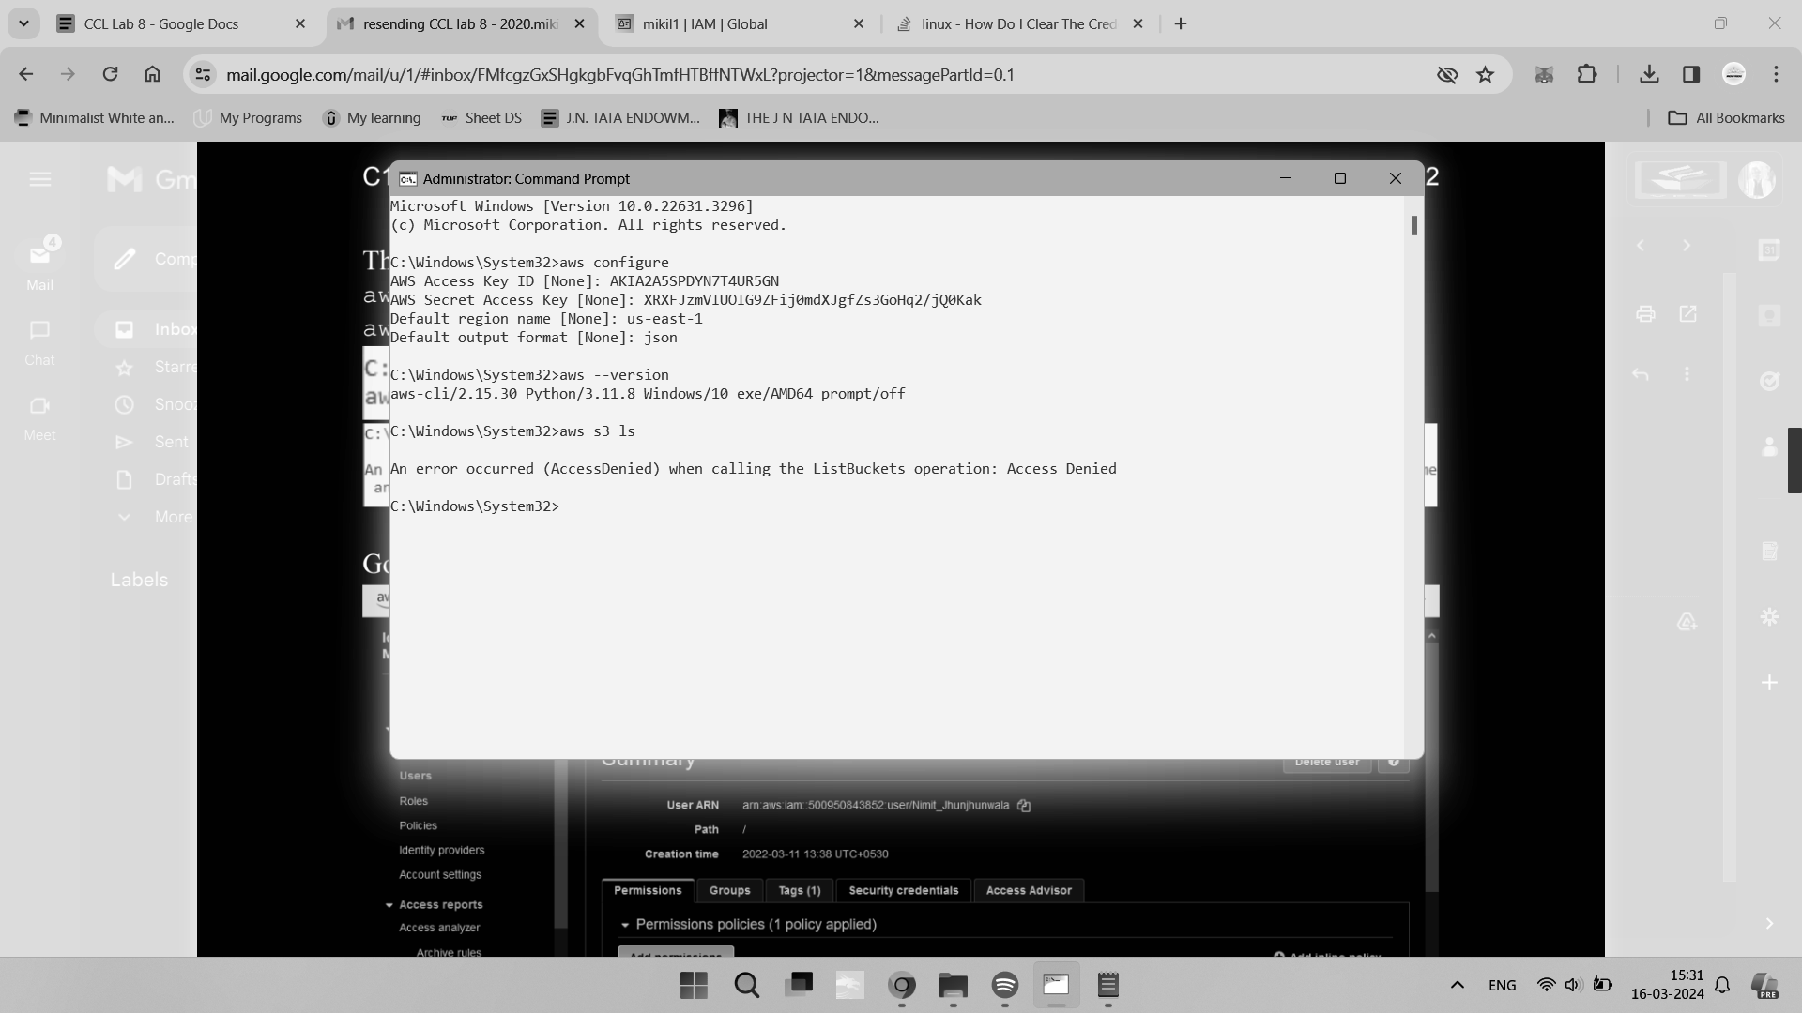

The next two steps are OPTIONAL:

aws –version

aws s3 ls



Go in the security credentials tab under Users of IAM Dashboard

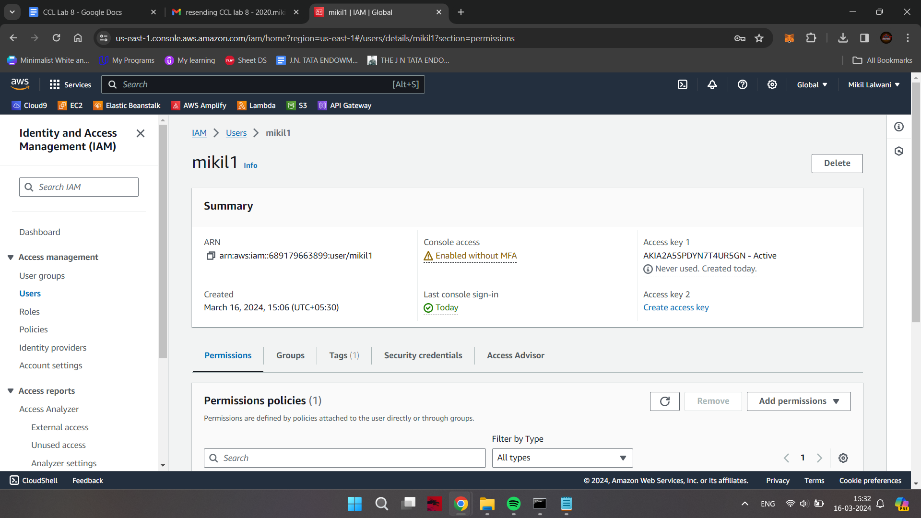

Click on the “Assign MFA Device” Hyperlink

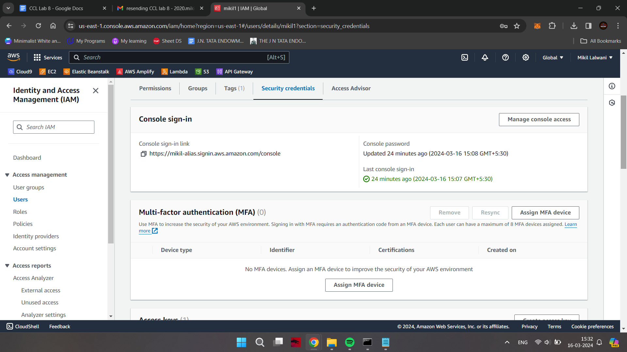

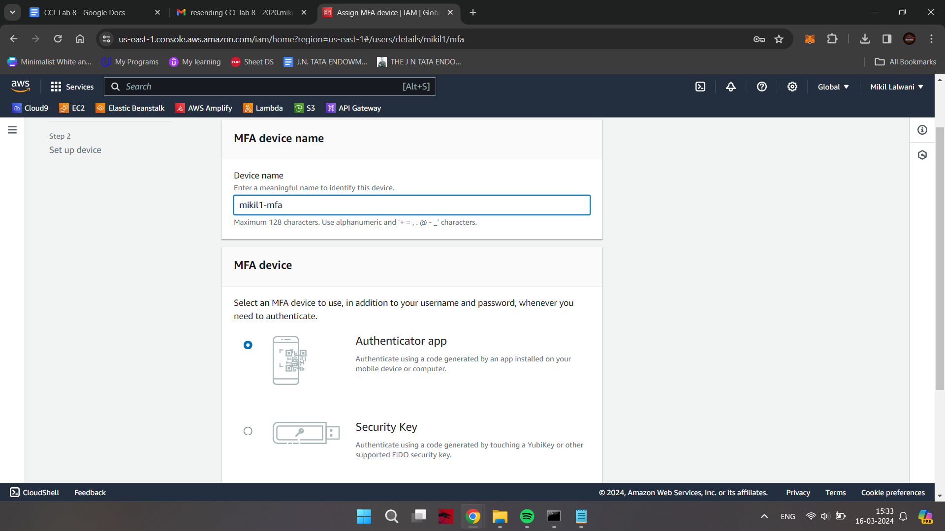

Use the Google Authenticator app downloaded earlier to scan the QR Code

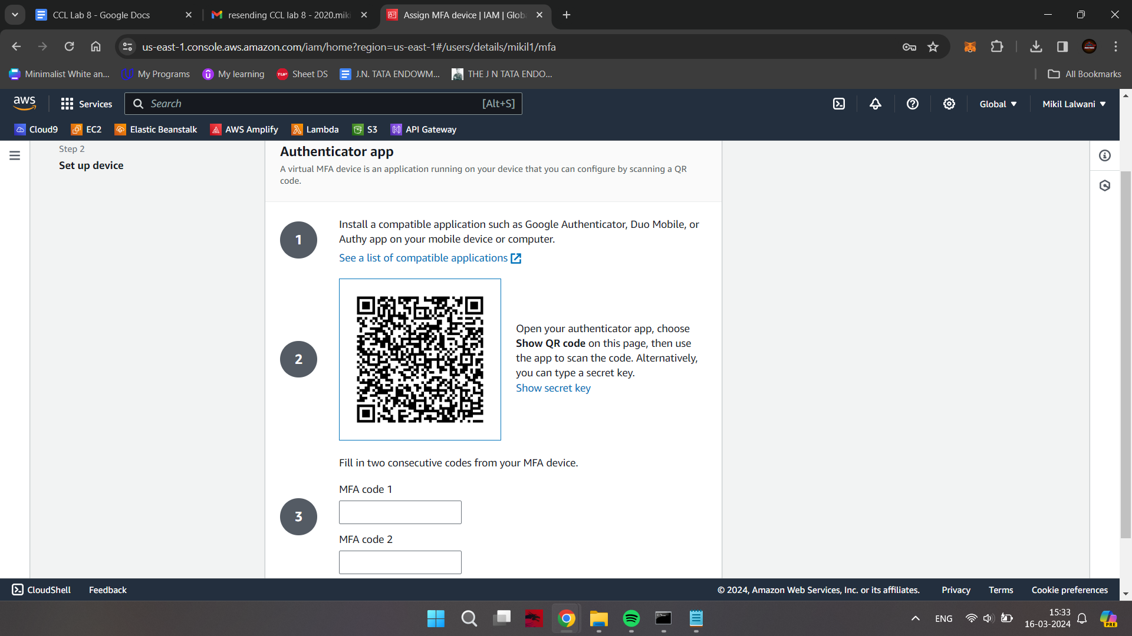

Enter two of the codes which are shown in the Google Authenticator App over a span of 30 secs each; click on Assign MFA Button

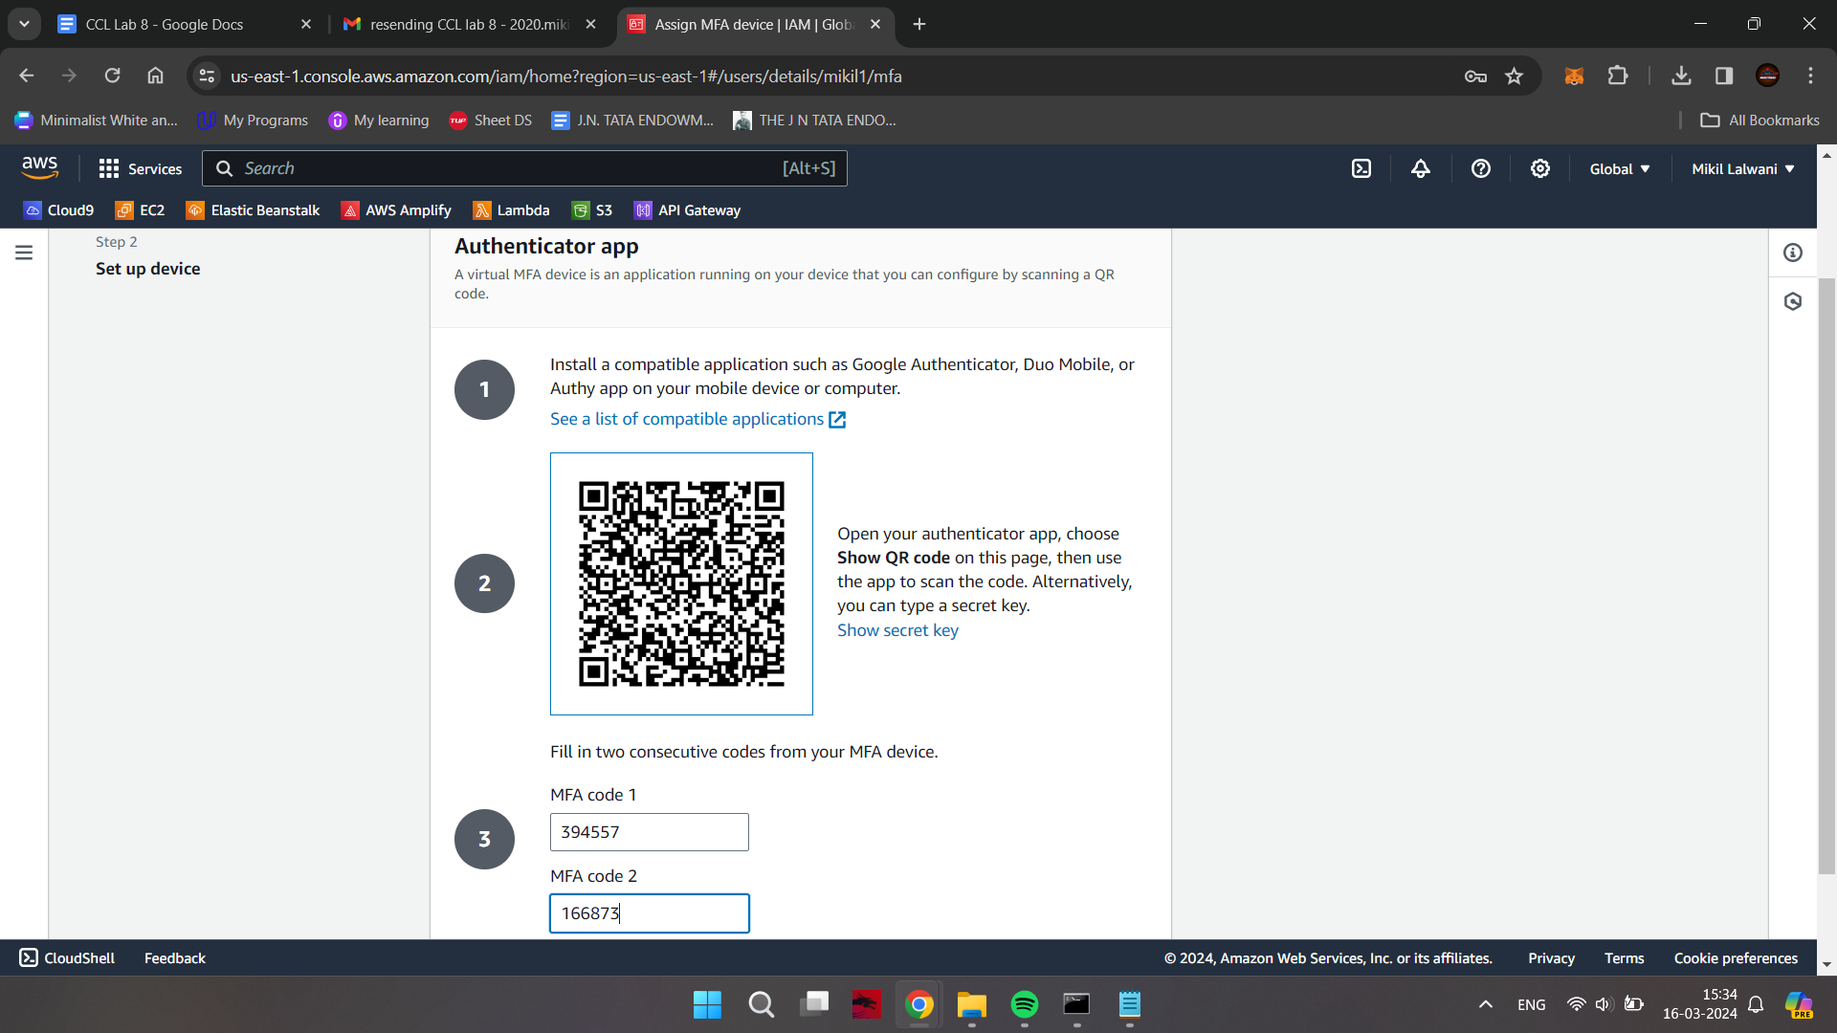

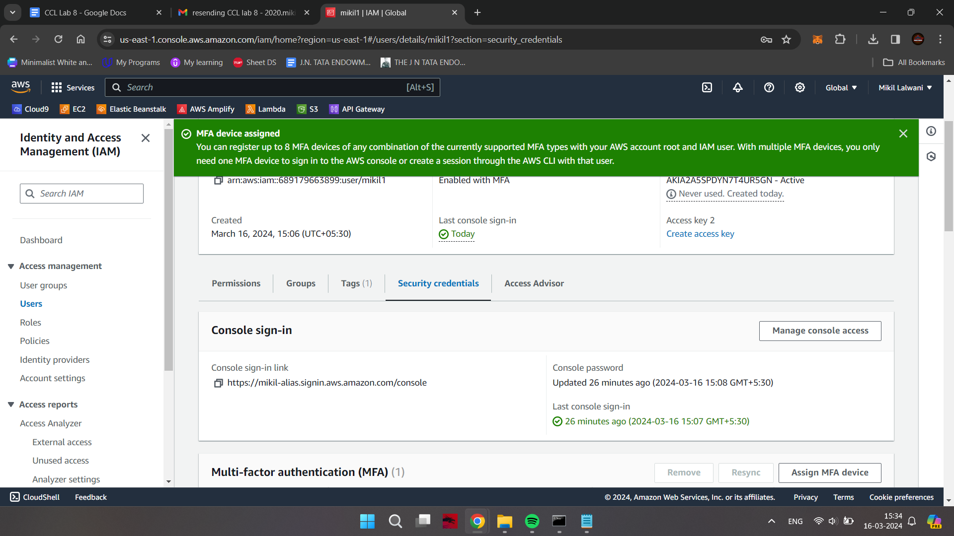

**Logging in as the new user after MFA**

Again try logging in via the new user created earlier; this time it will ask for MFA after you click on Sign In

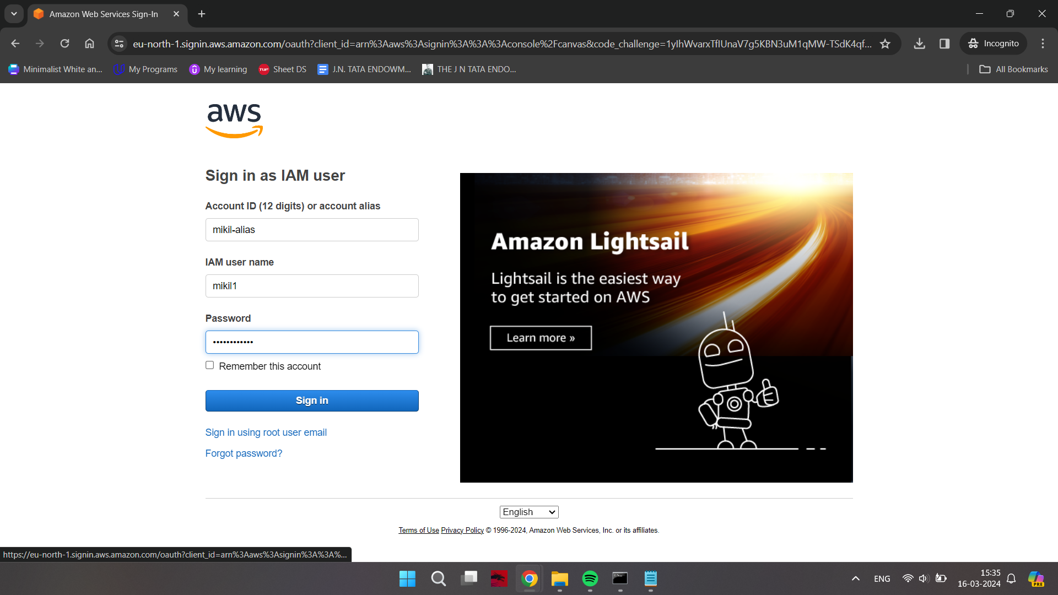

Use the code being shown in the Google Authenticator

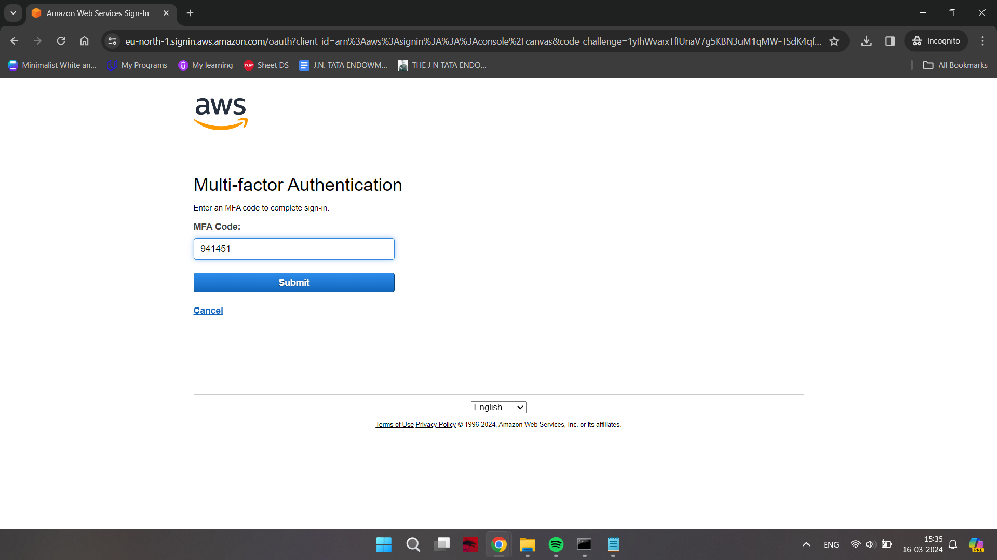

Now, after opening the root user window again

After going in the Users section of IAM Dashboard, we can see that MFA has been activated for the new user

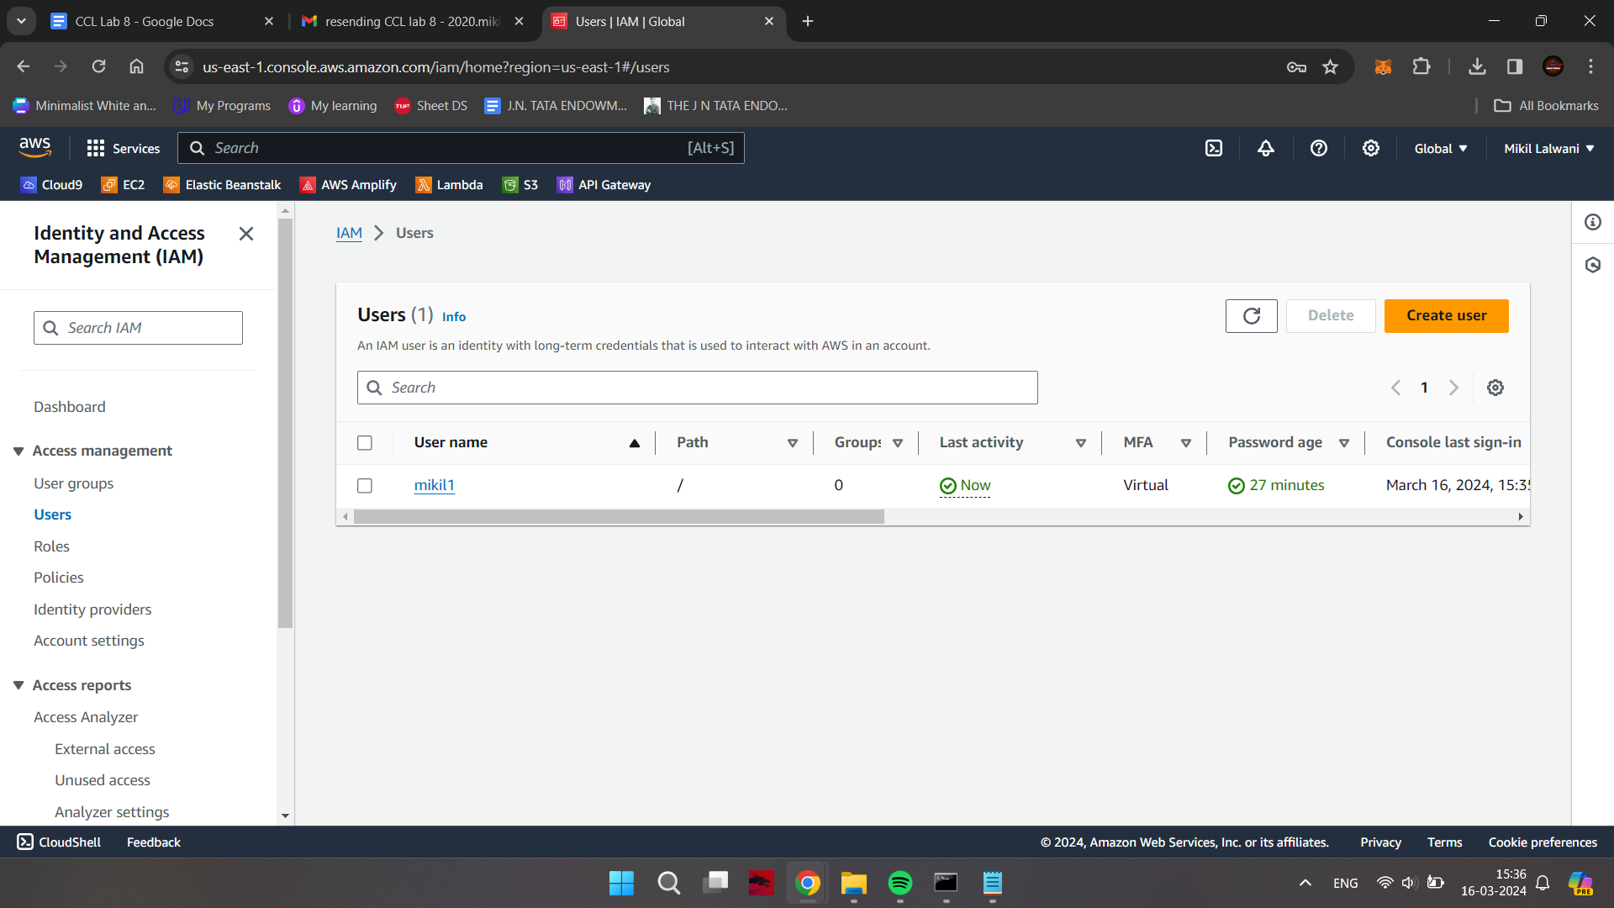

**Adding 2 More Users and Giving them permissions**

Now, Adding 2 More Users

Not giving them an Access key and not checking the Psw Reset Checkbox; Click on the Next: Permissions

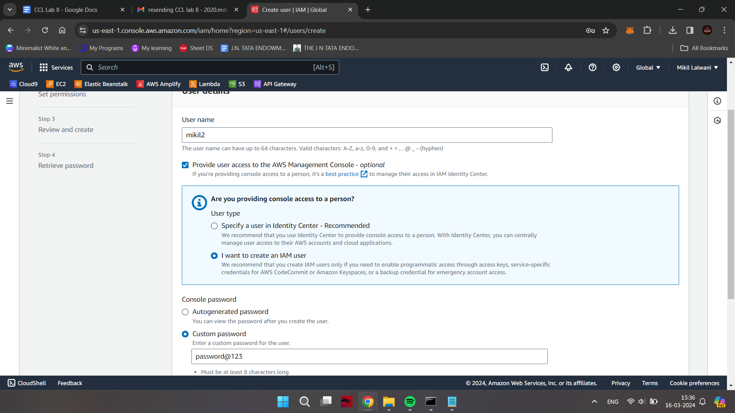

We will create a group later

We can see the previous user listed under the copy “permission from existing user” section (just for observation purpose)

Click on the third section: Attach existing policies directly

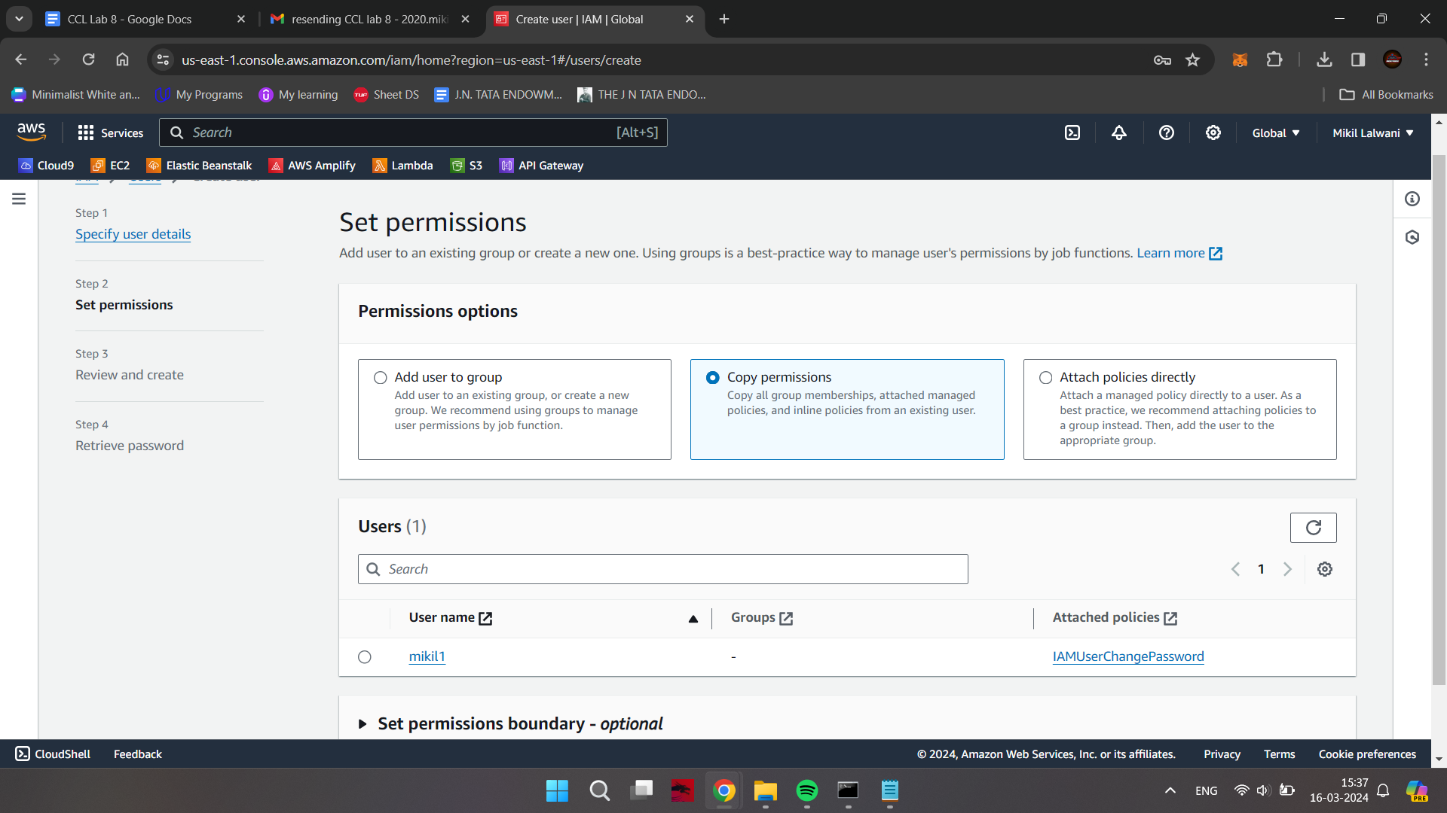

Type in *ec2fullaccess* in the search box and click the check box for it; click on Next

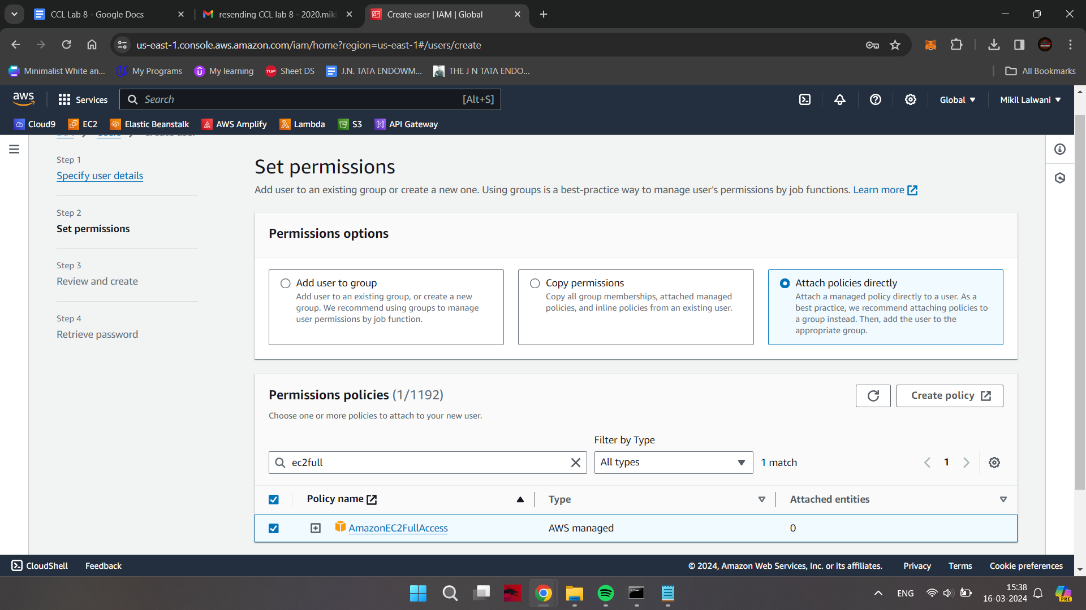

Logging in as one of the 2 new Users and Checking their permissions

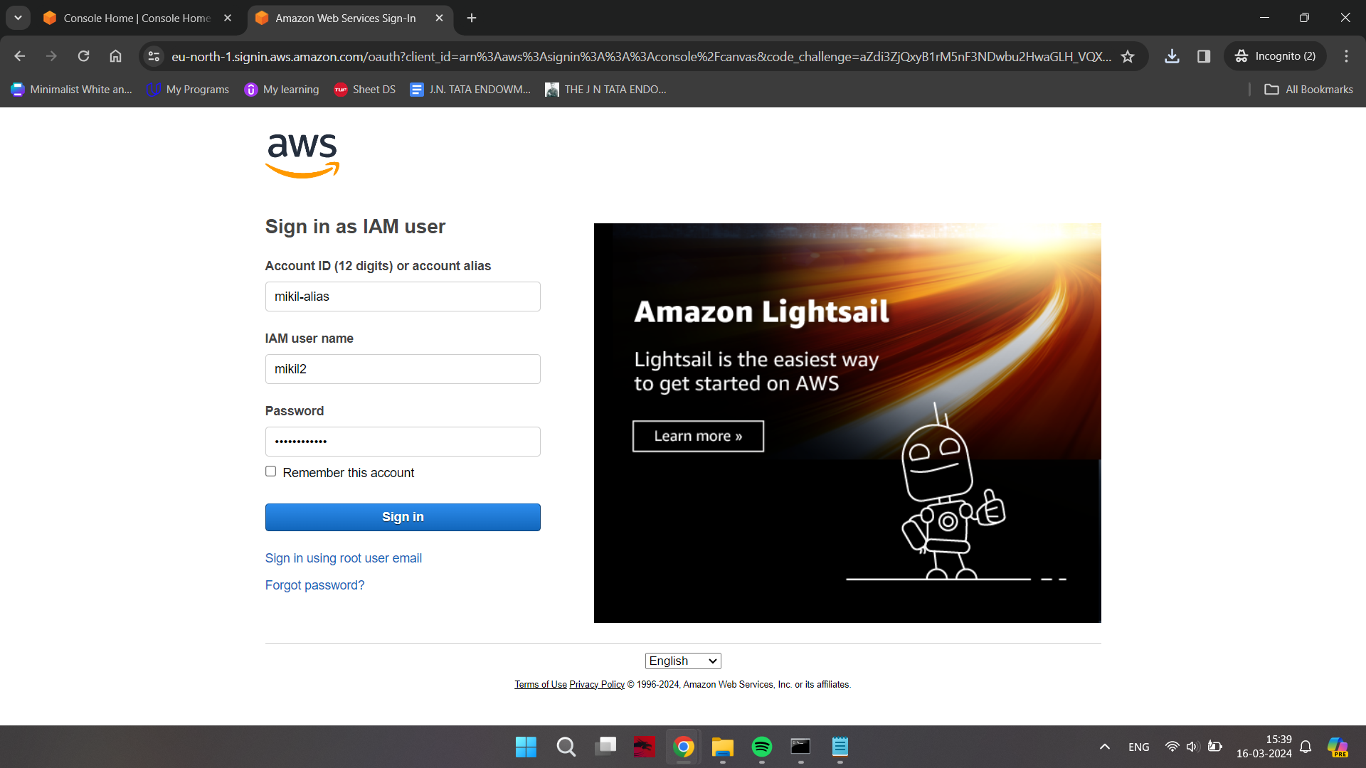

Try launching an EC2 instance via the new user

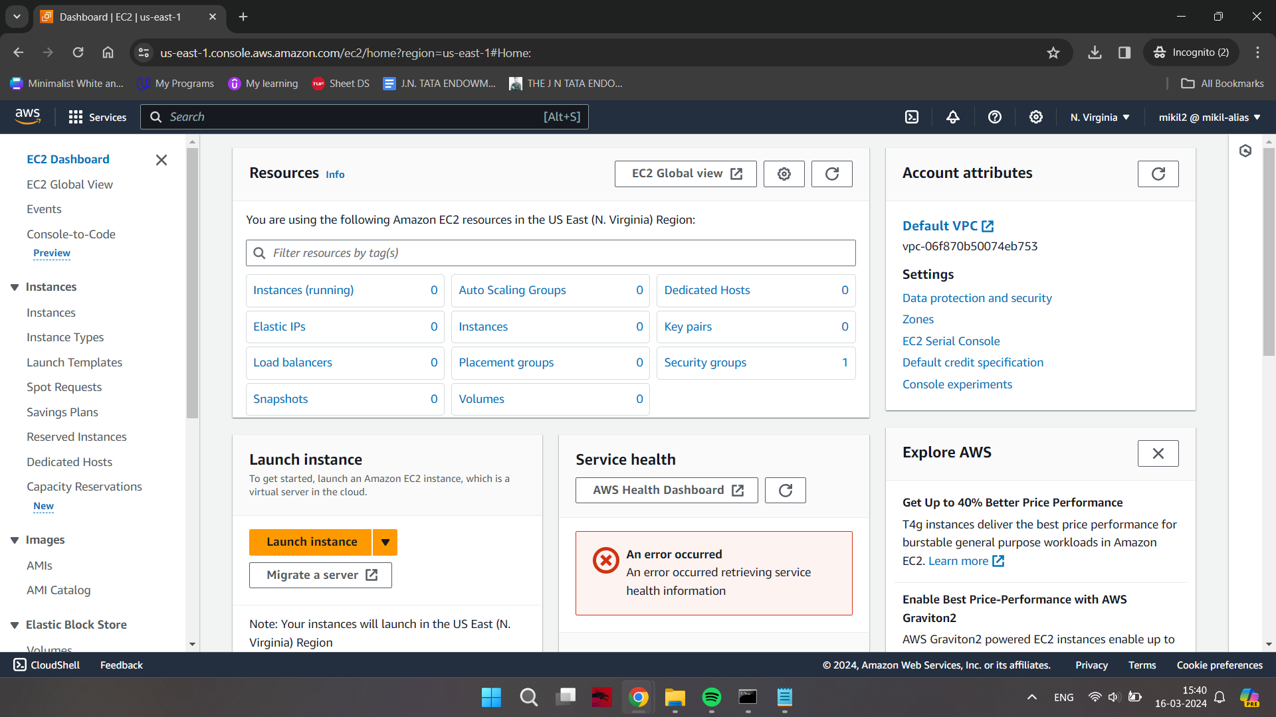

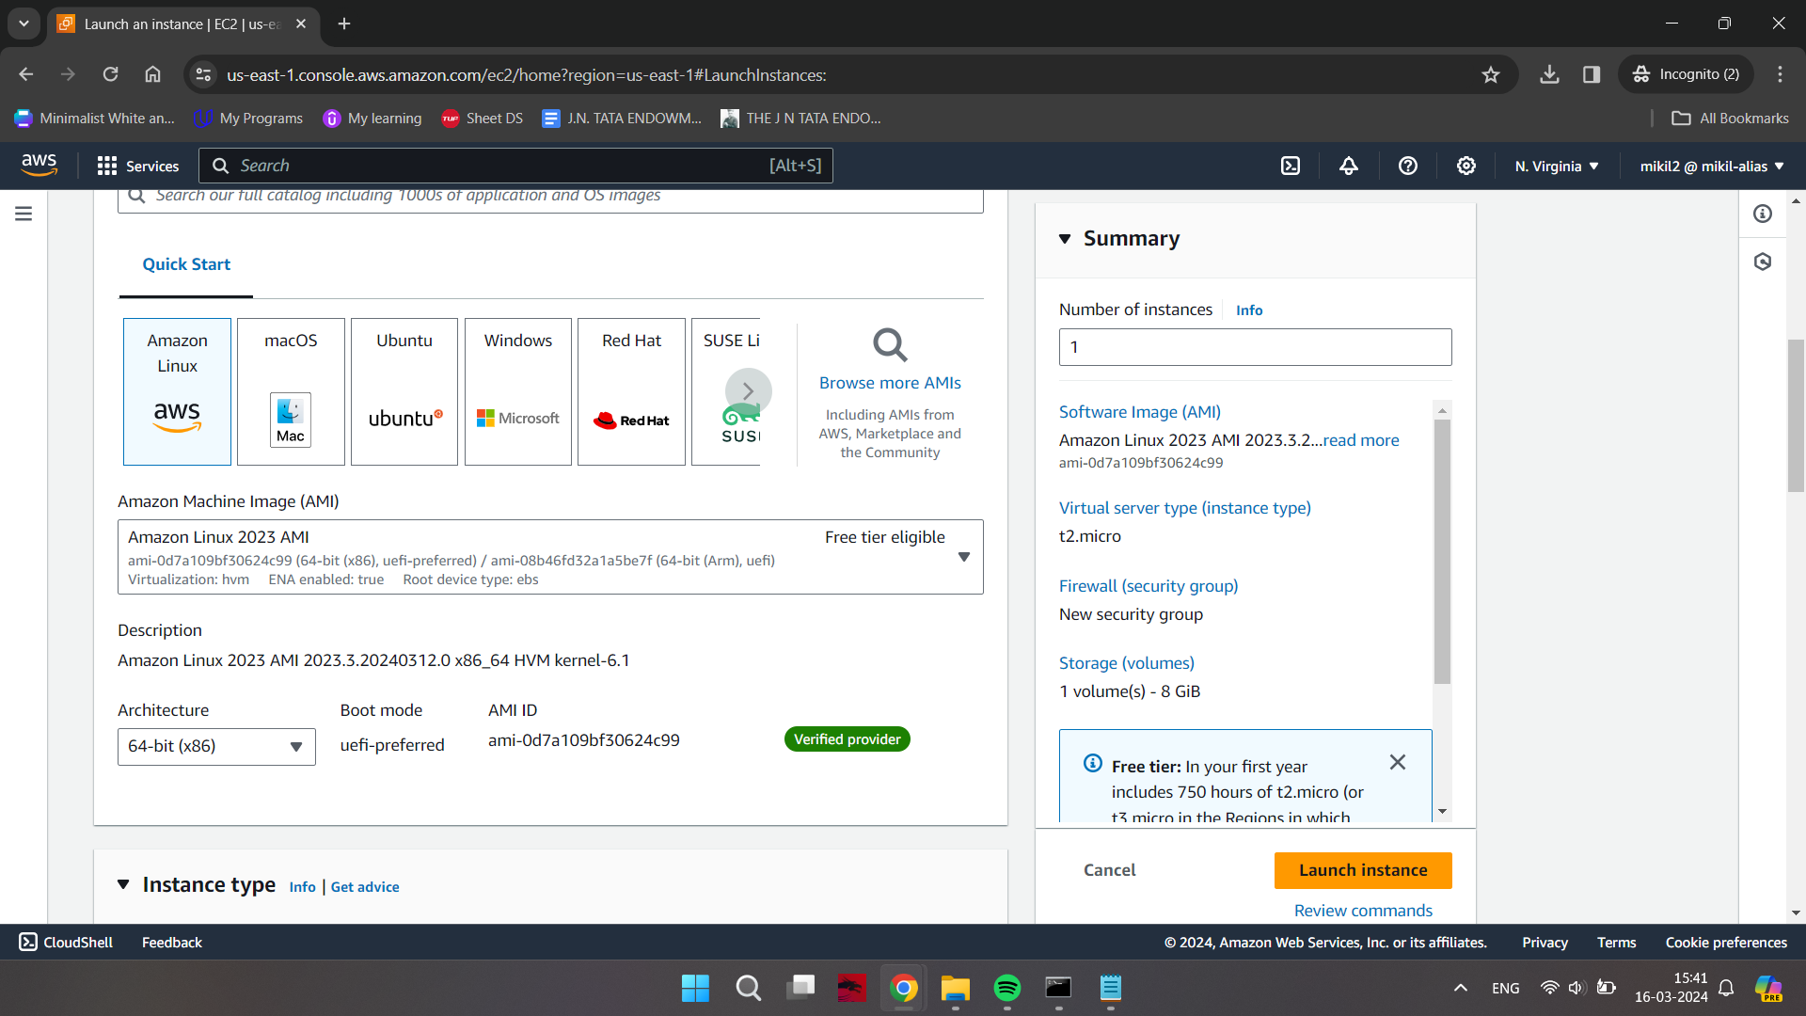

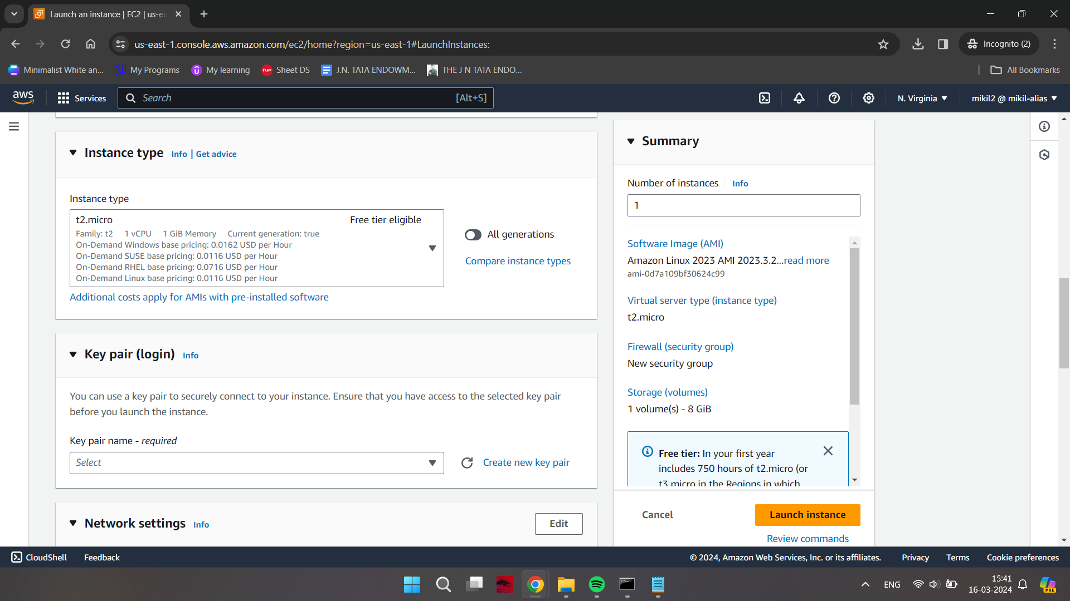

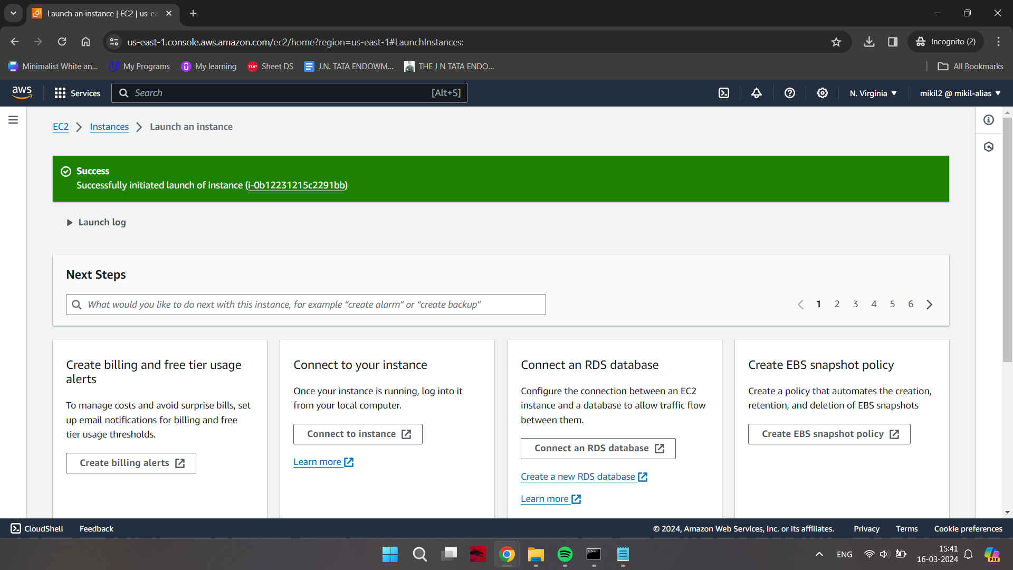

Hence, an instance has been created

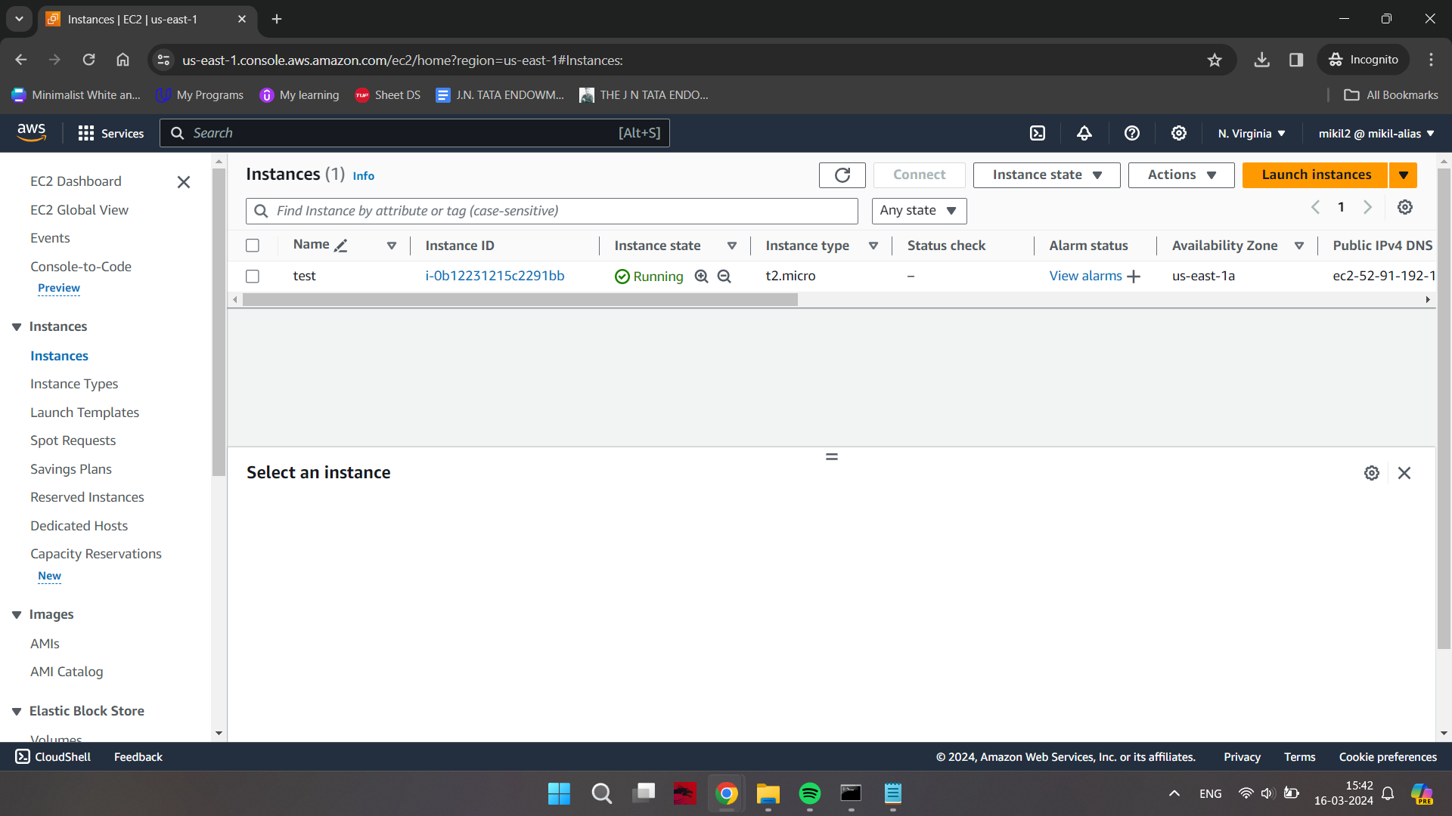

Delete the bucket when done with your work

**Creating a new Group and Giving it permissions**

Select the members to be present in the group (max 4 per group)

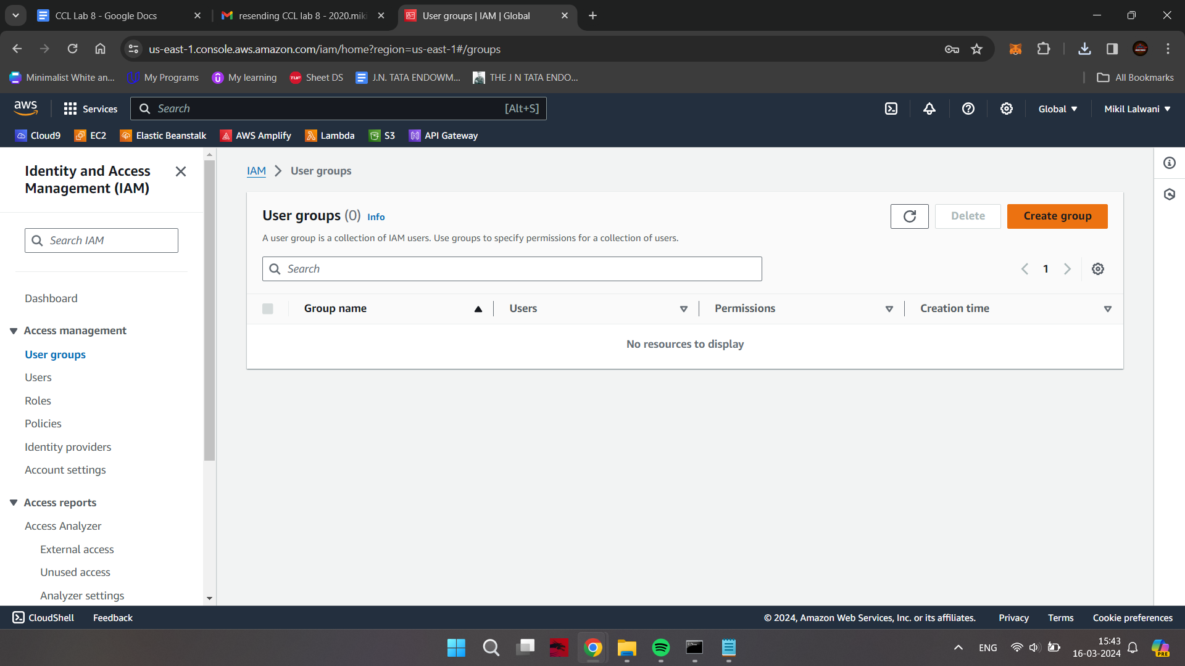

Giving this group *ec2fullaccess* and *s3fullaccess*

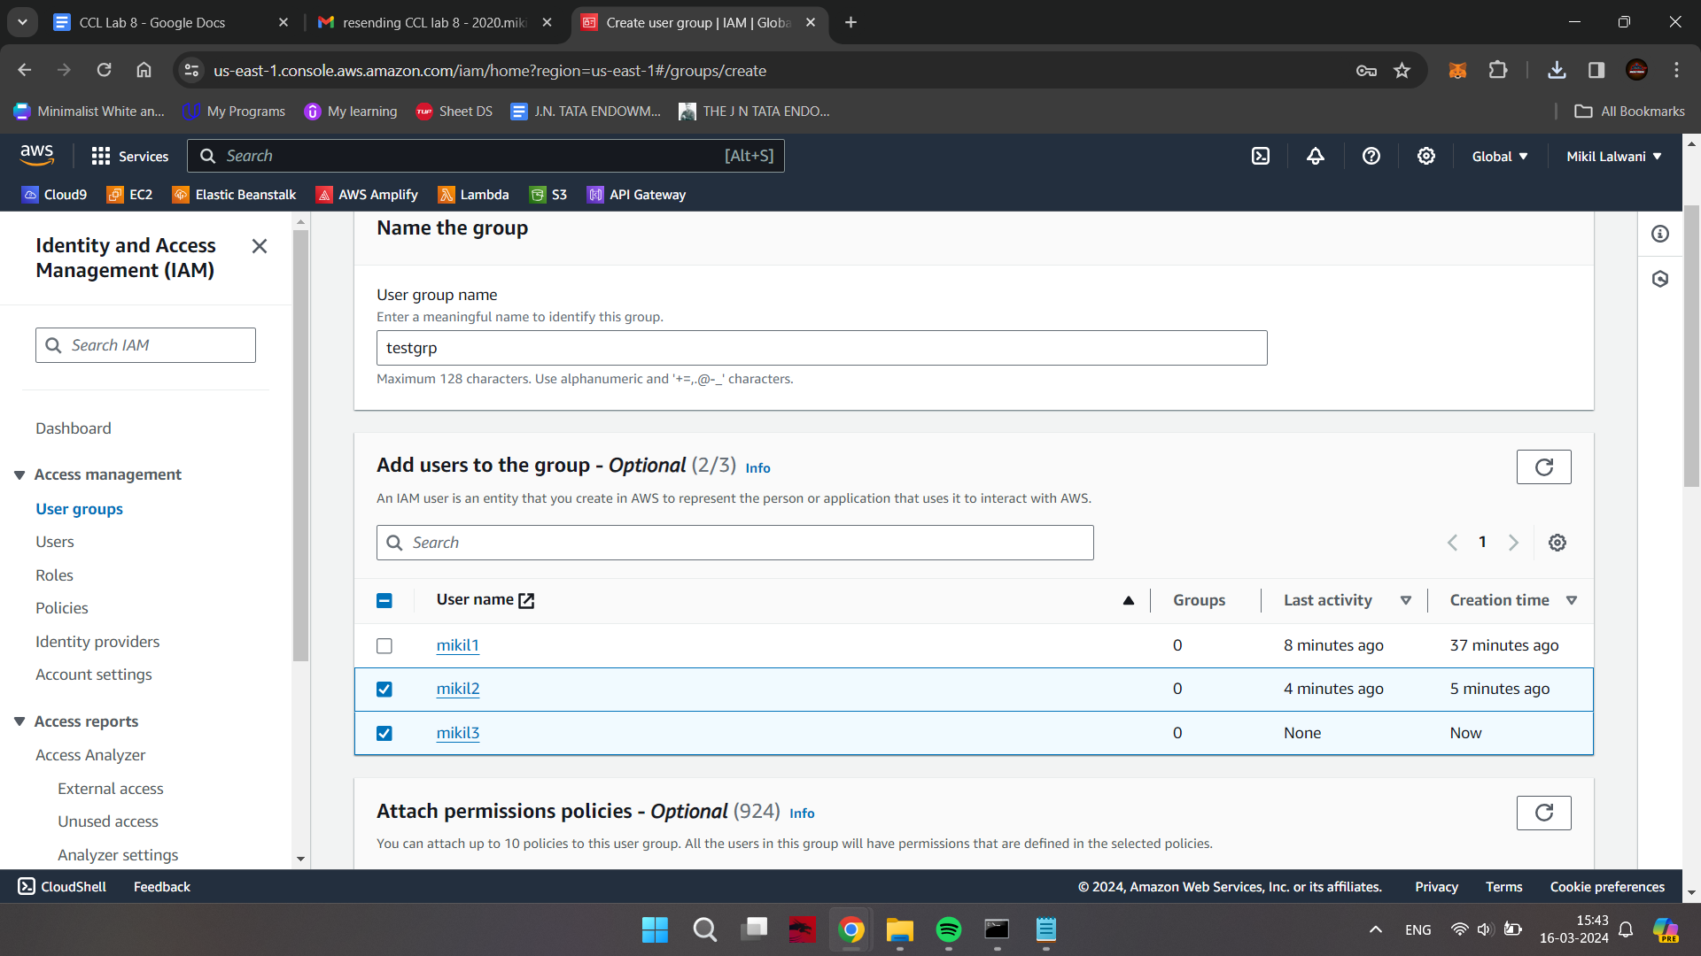

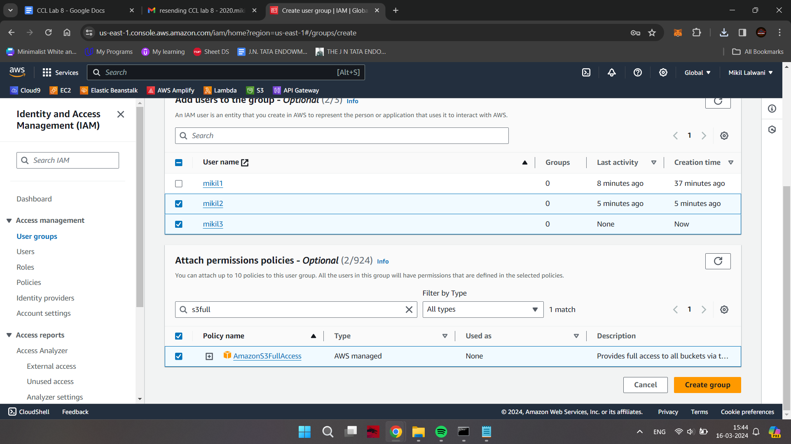

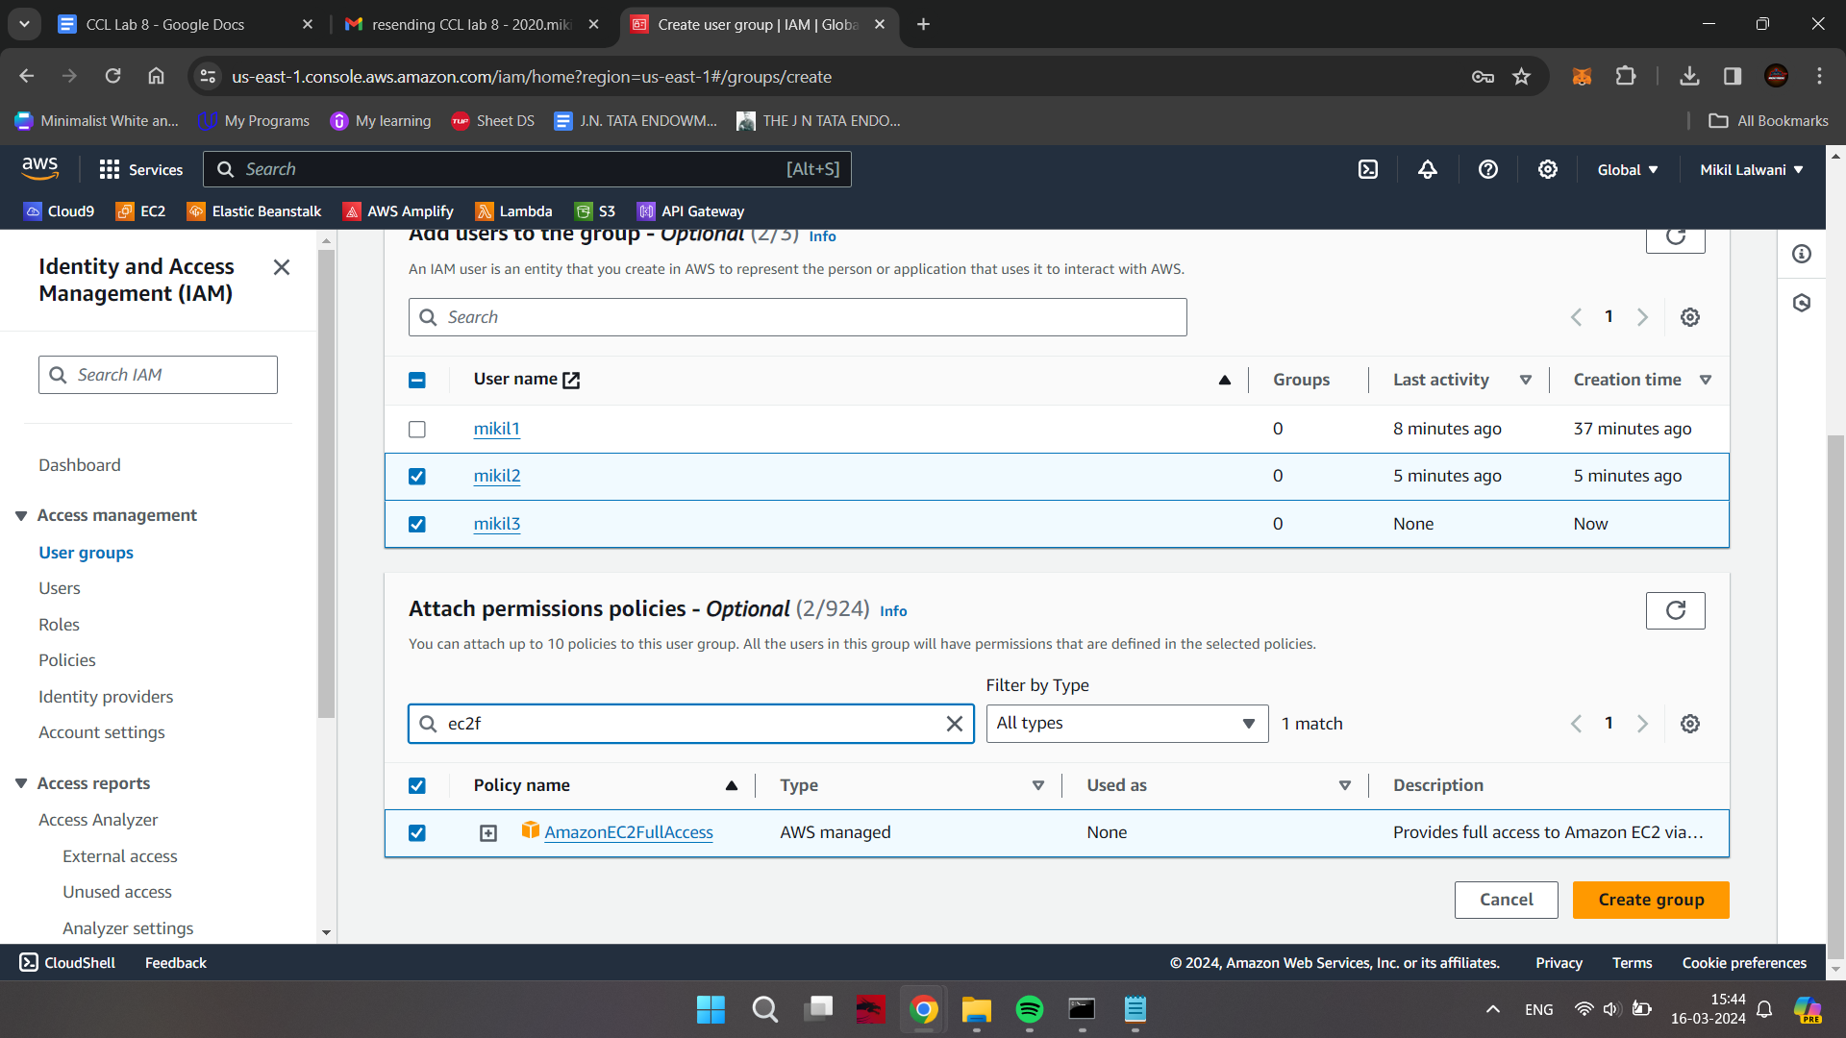

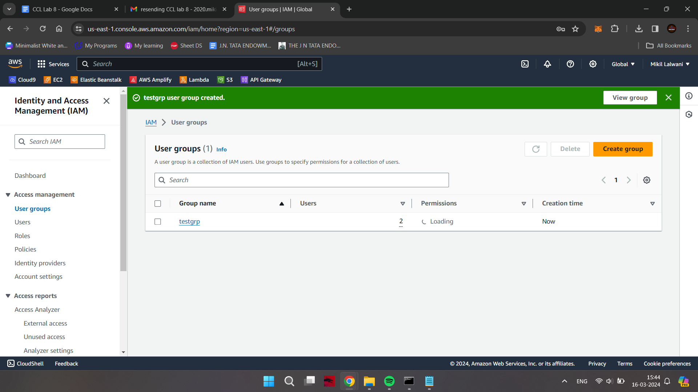

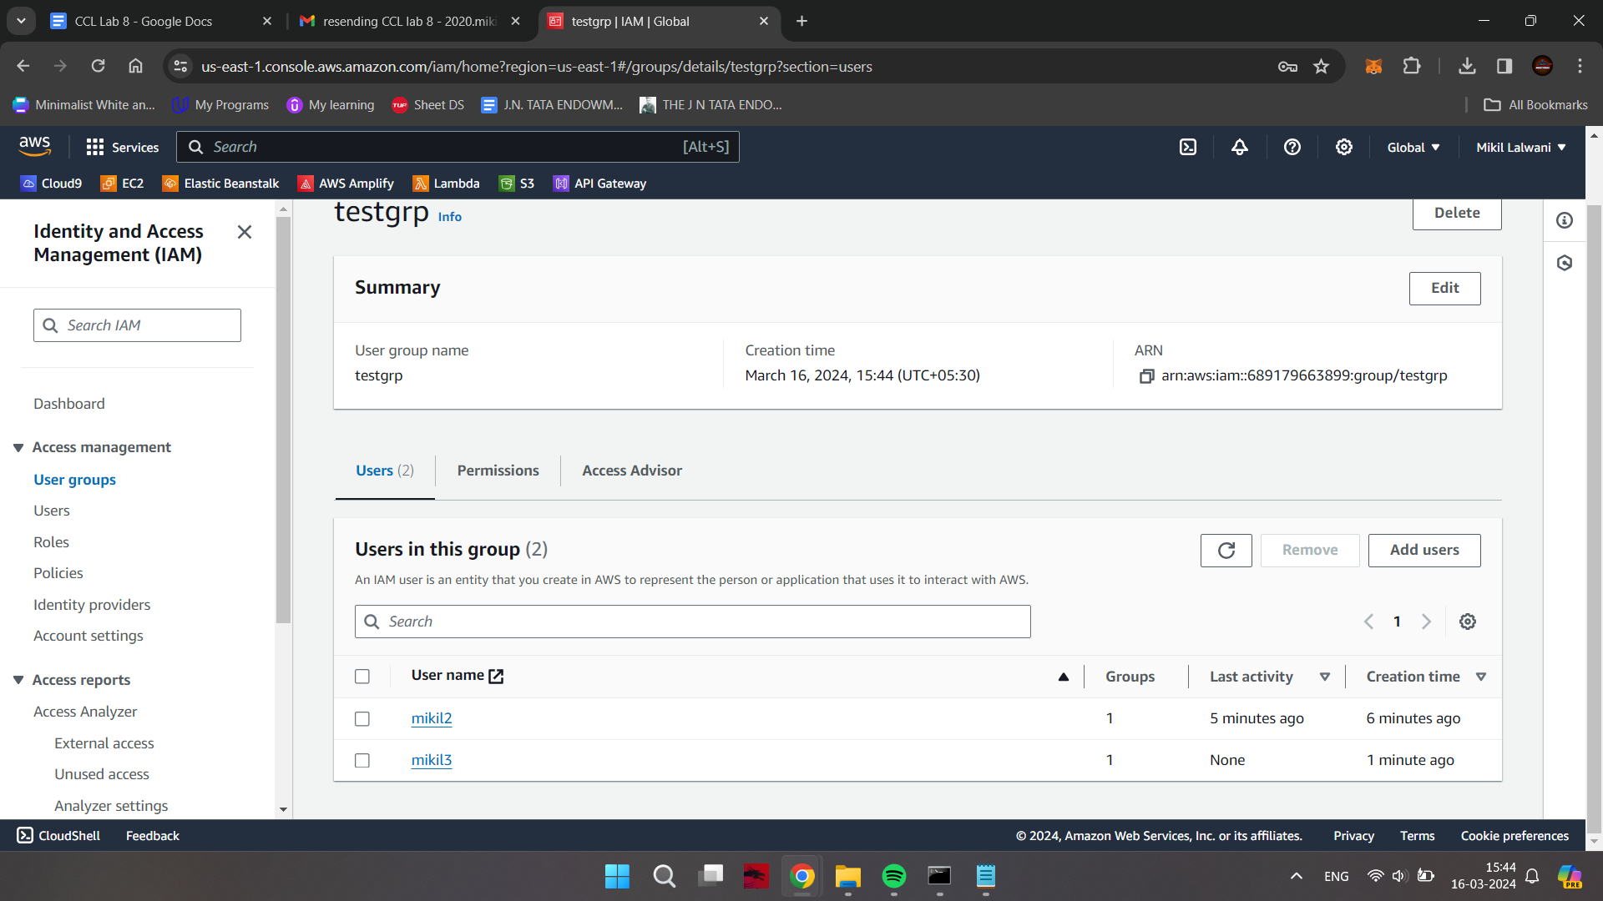

**Logging in as a member of the Group & Checking their permissions**

Now, login as one of the users from the group and try creating a S3 bucket

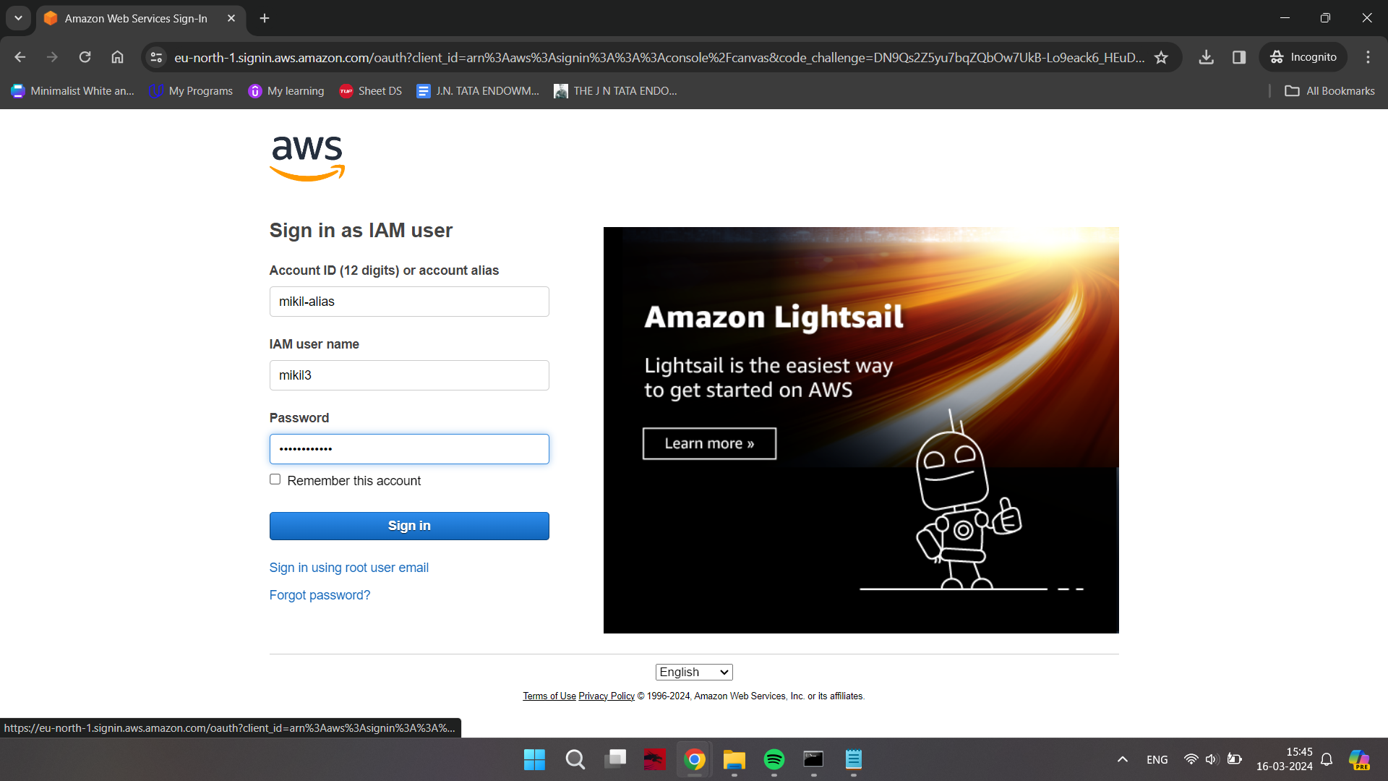

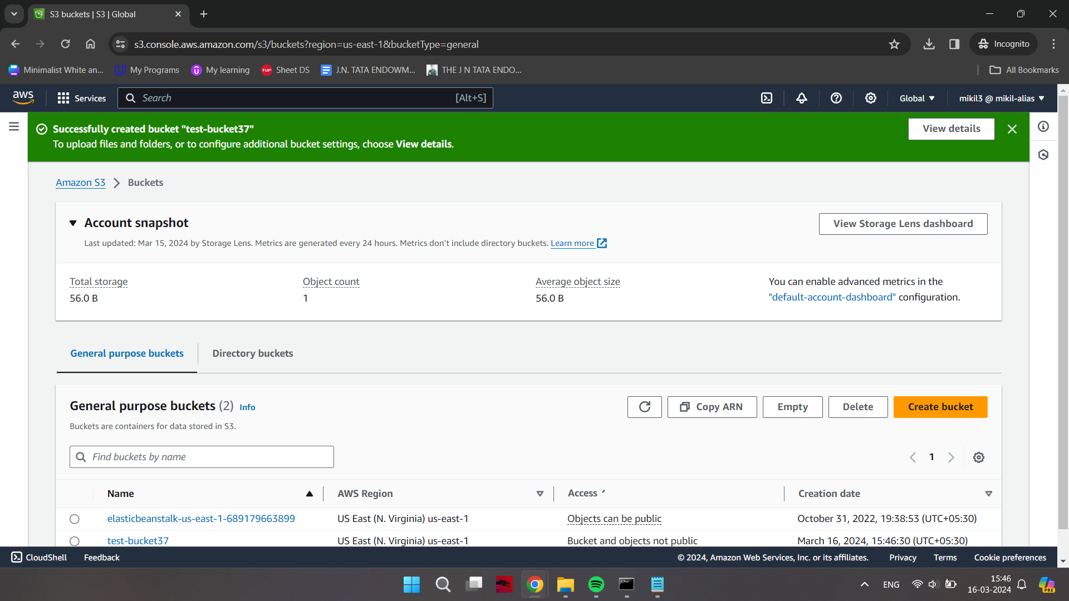

Delete the bucket when done with your work

**Creating a new Role**

Go in the root user window and click on “create role” button in the “Roles” section of IAM Dashboard

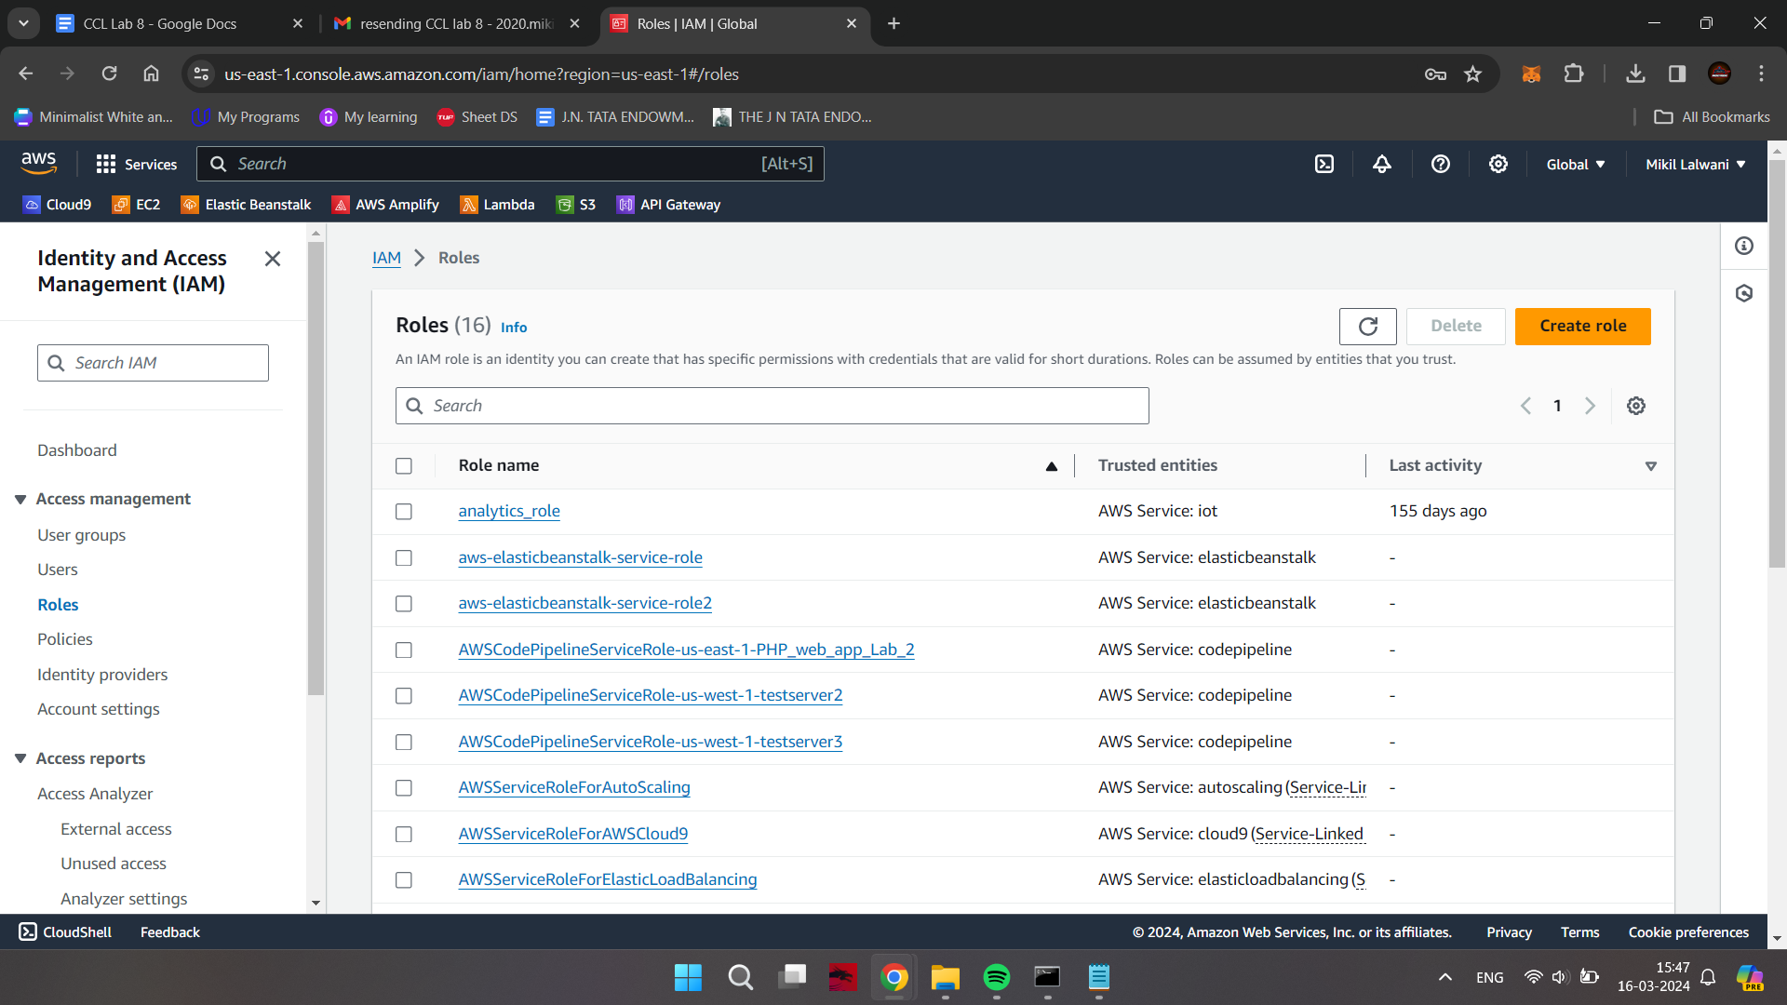

Let it be the default options (you can choose any use case you like)

Click in Next button

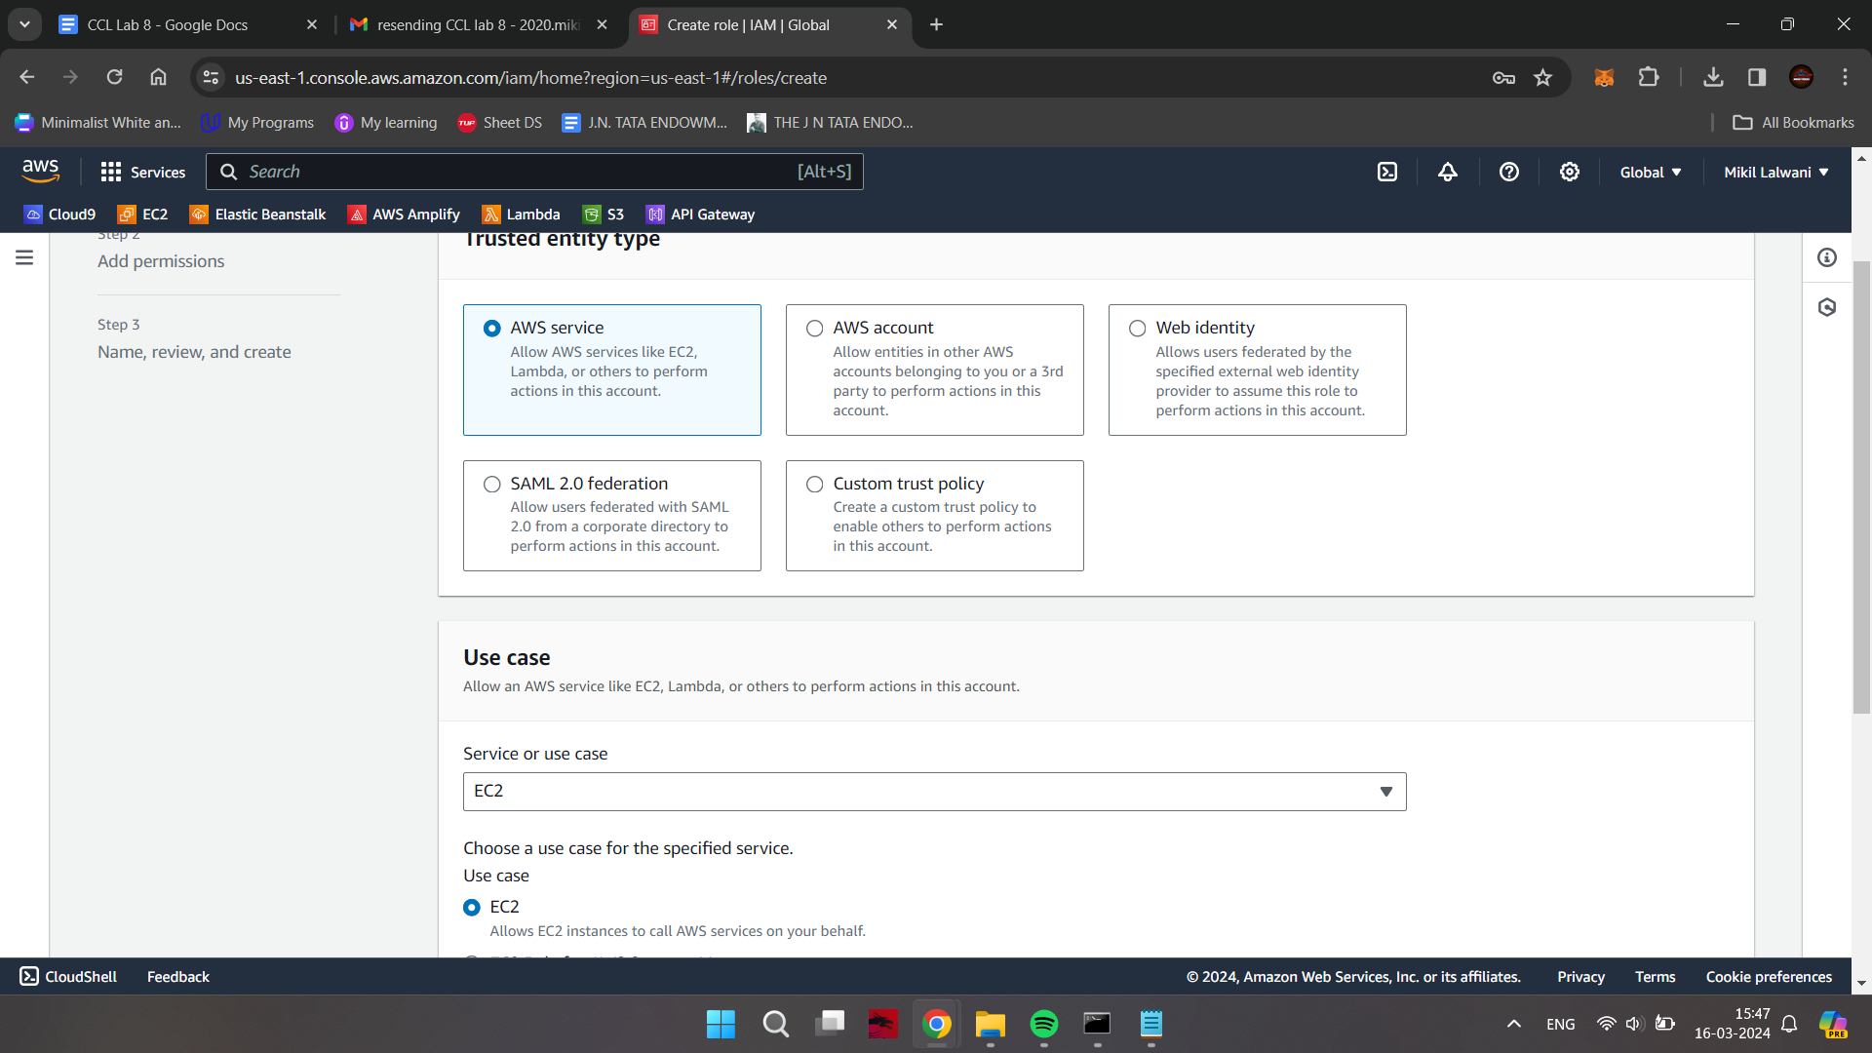

Give the permission suitable to the use case chosen

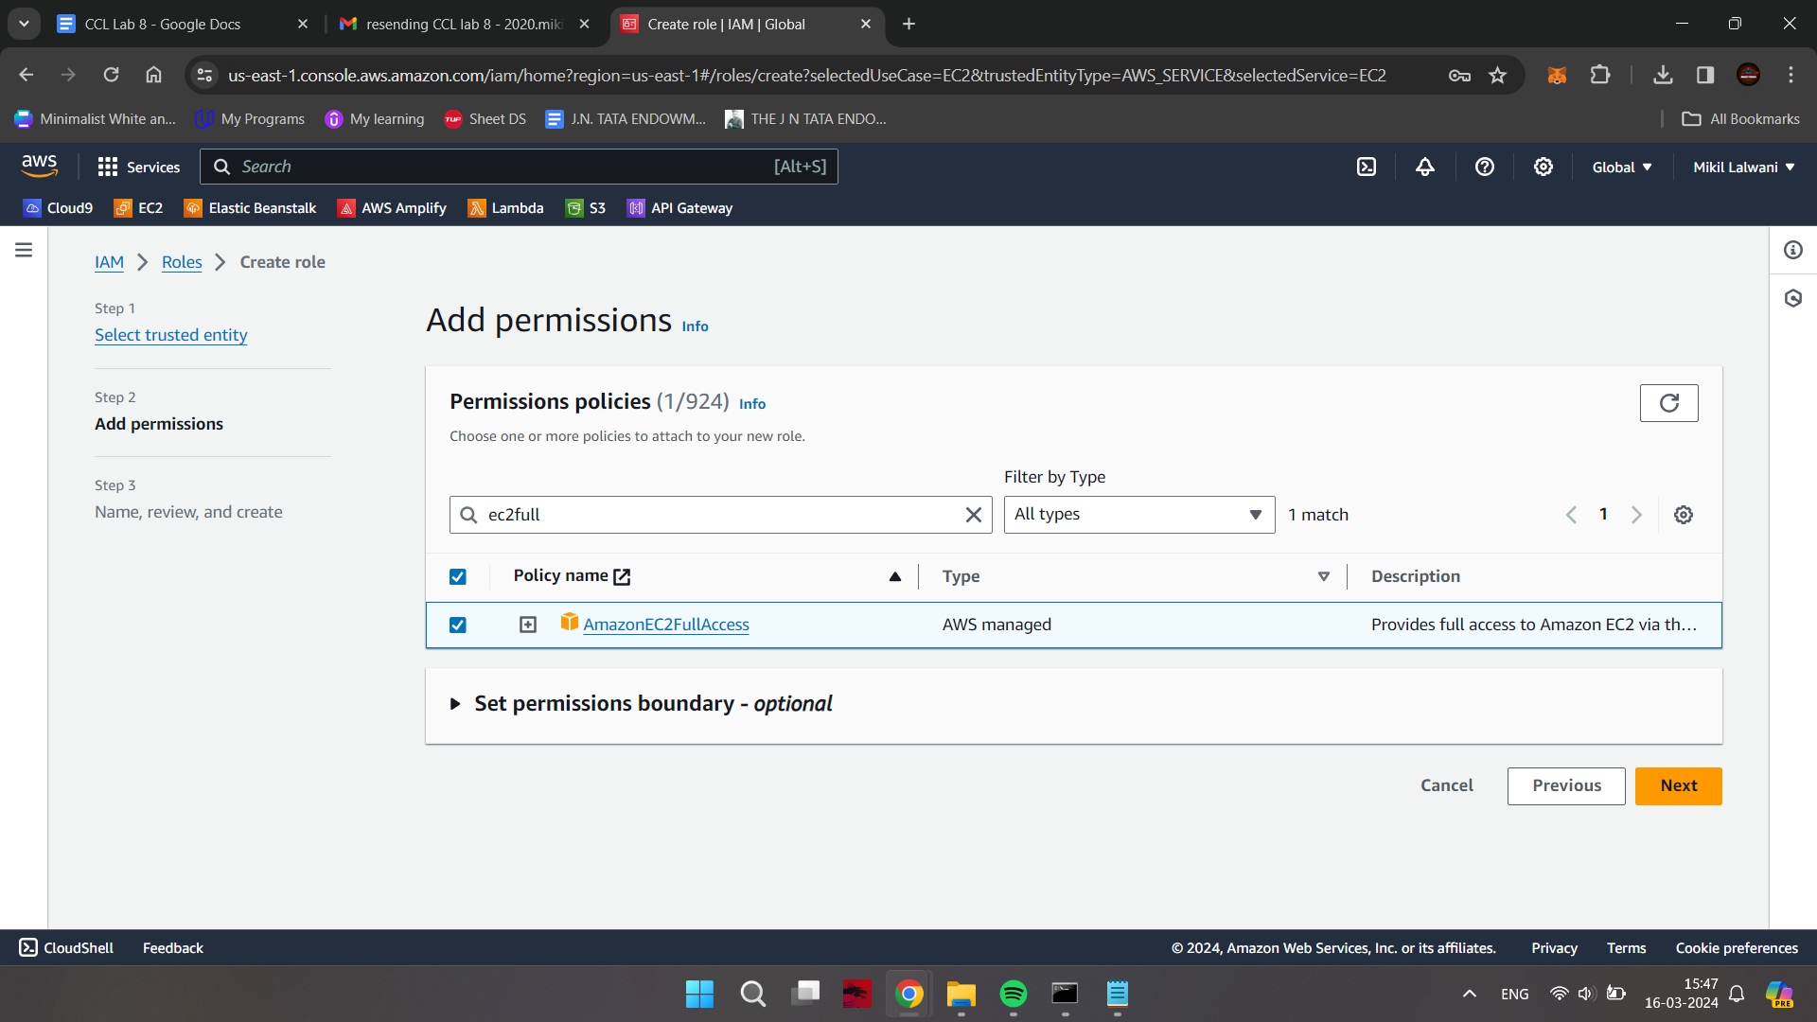

Give a suitable Role name and description; rest would remain as default. click on Create Role button

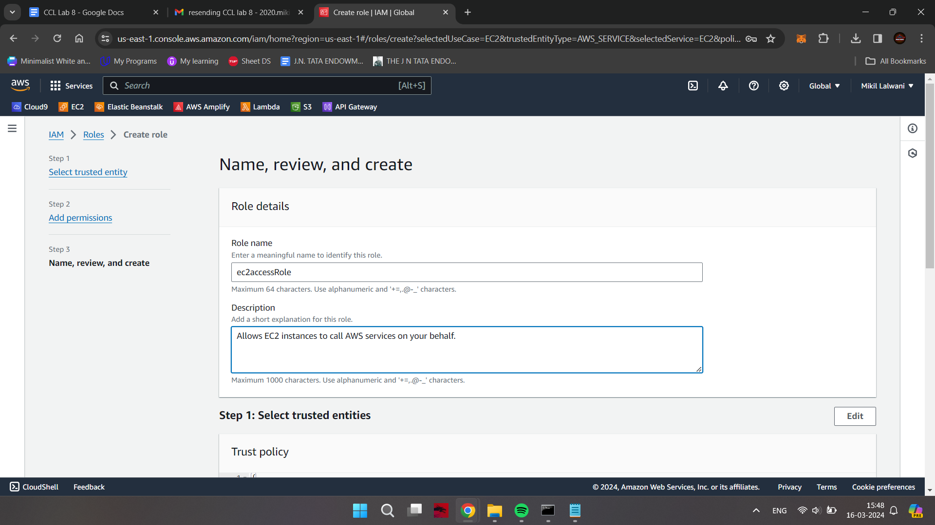

The role has been successfully created

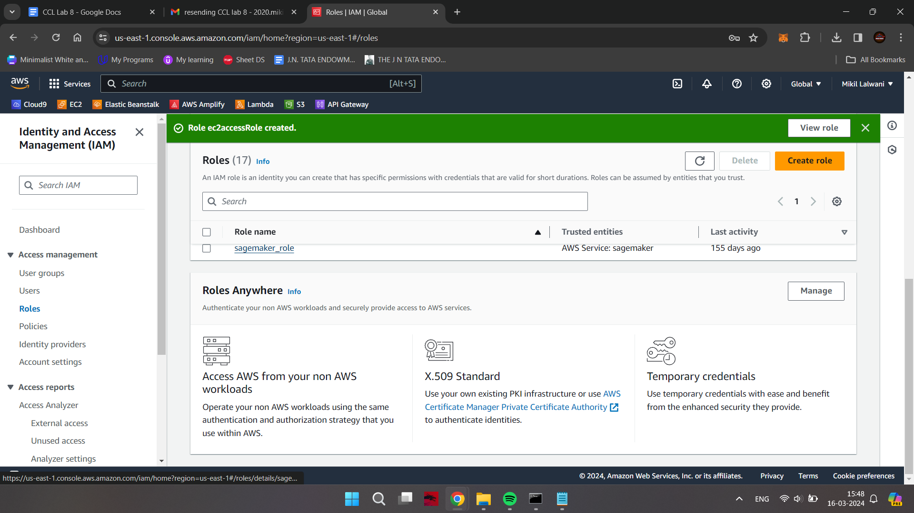

Just to check the overall users, groups and roles, you can check out the IAM Dashboard

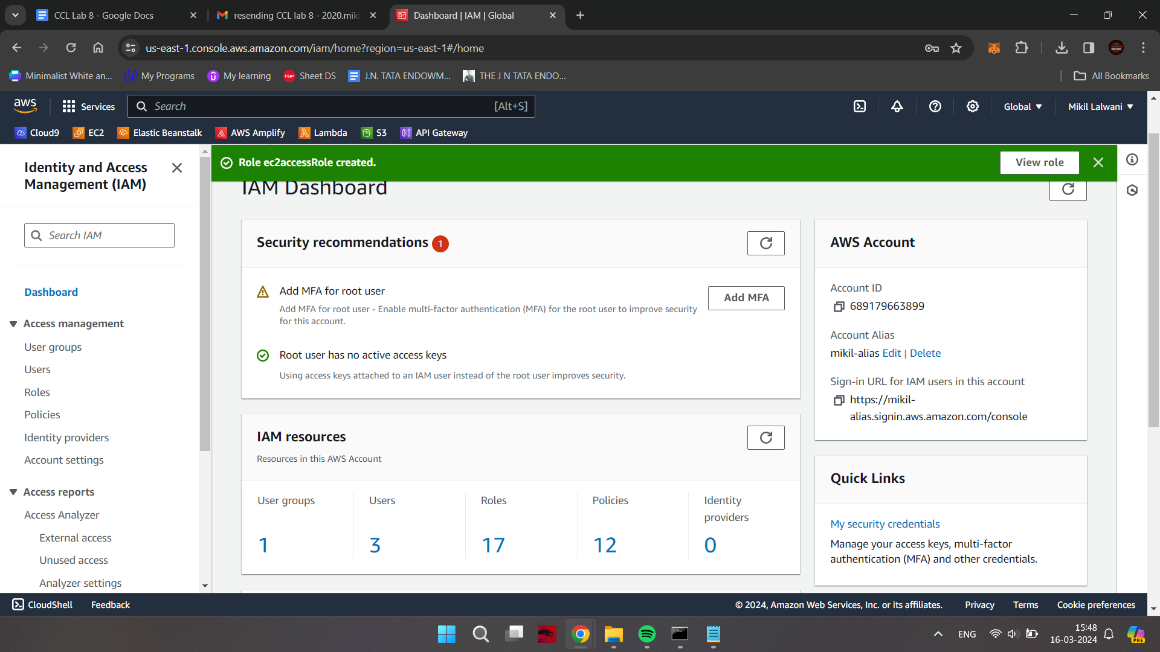

**Deleting a User**

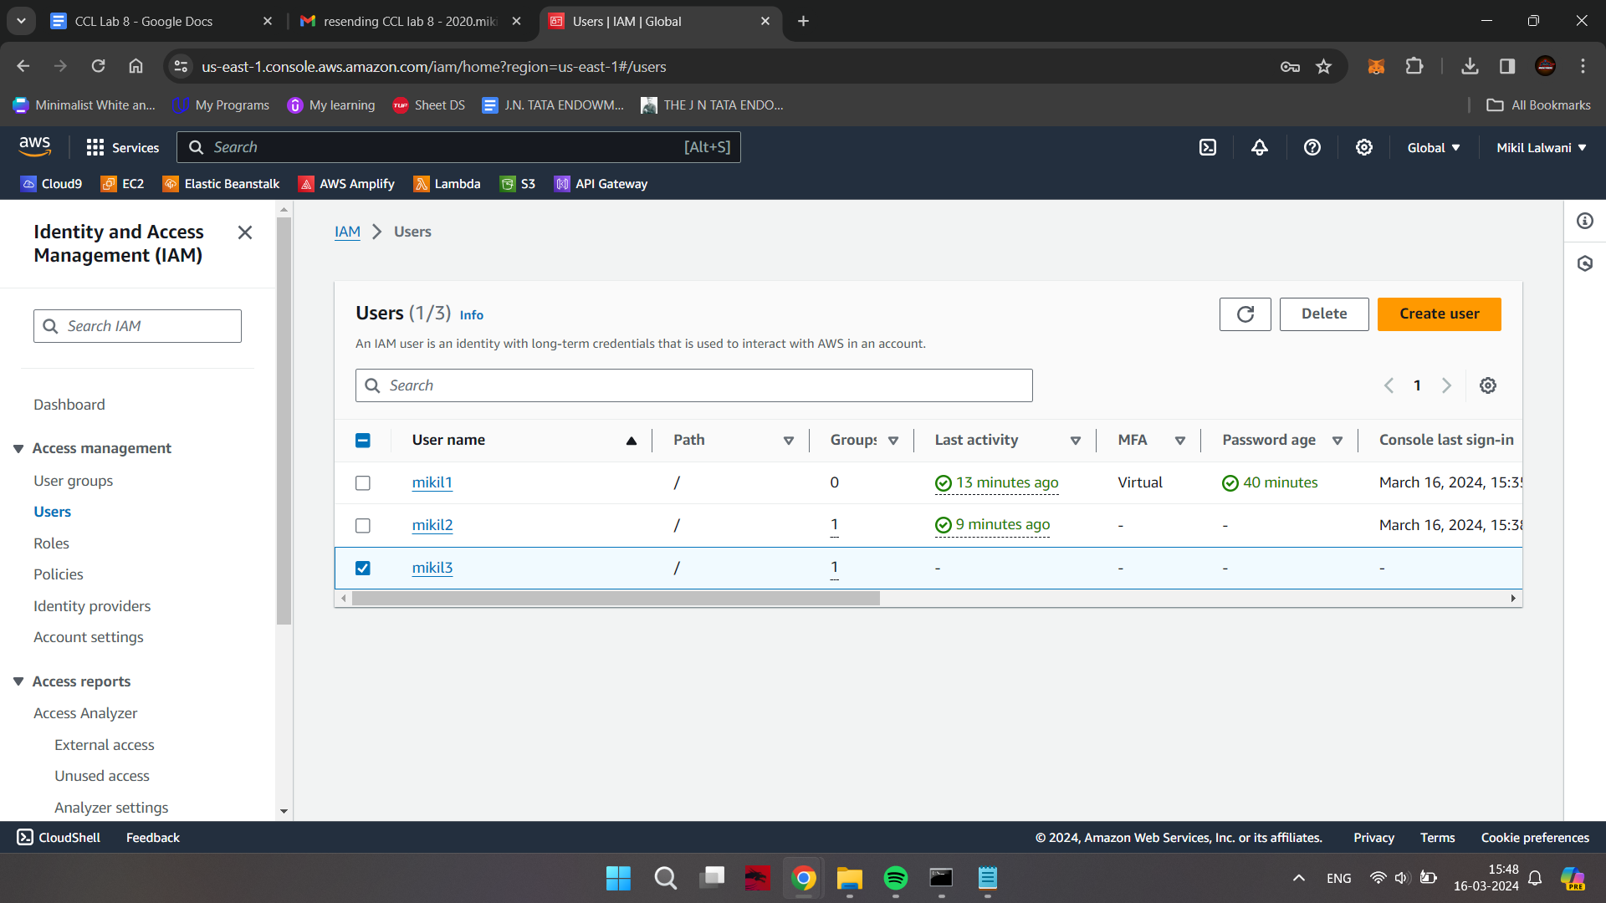

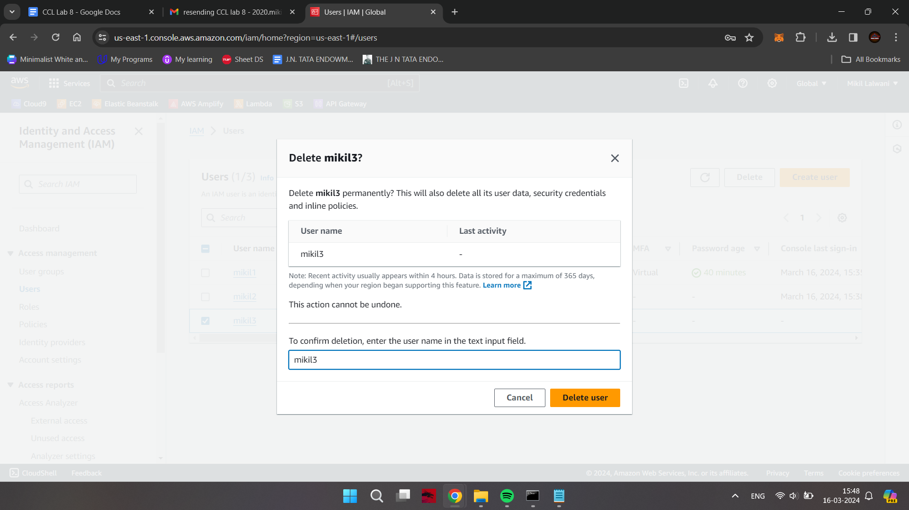

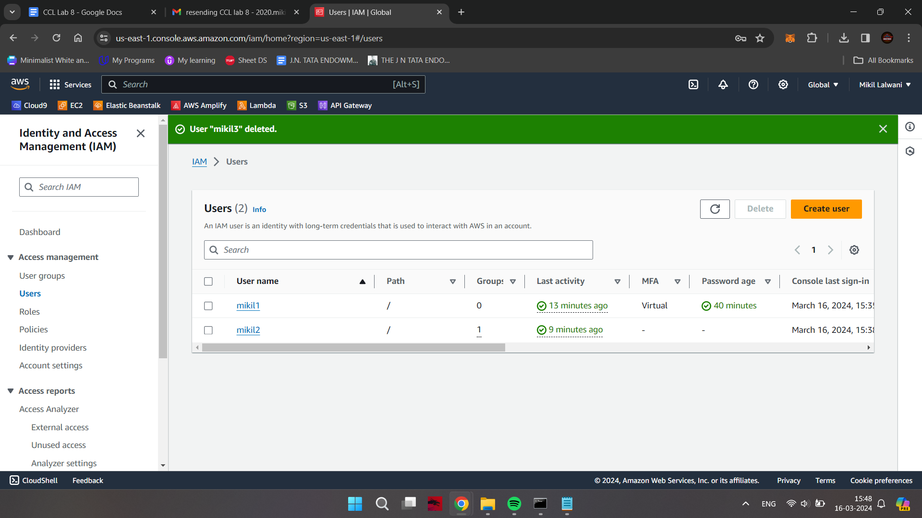

**Deleting a Role**

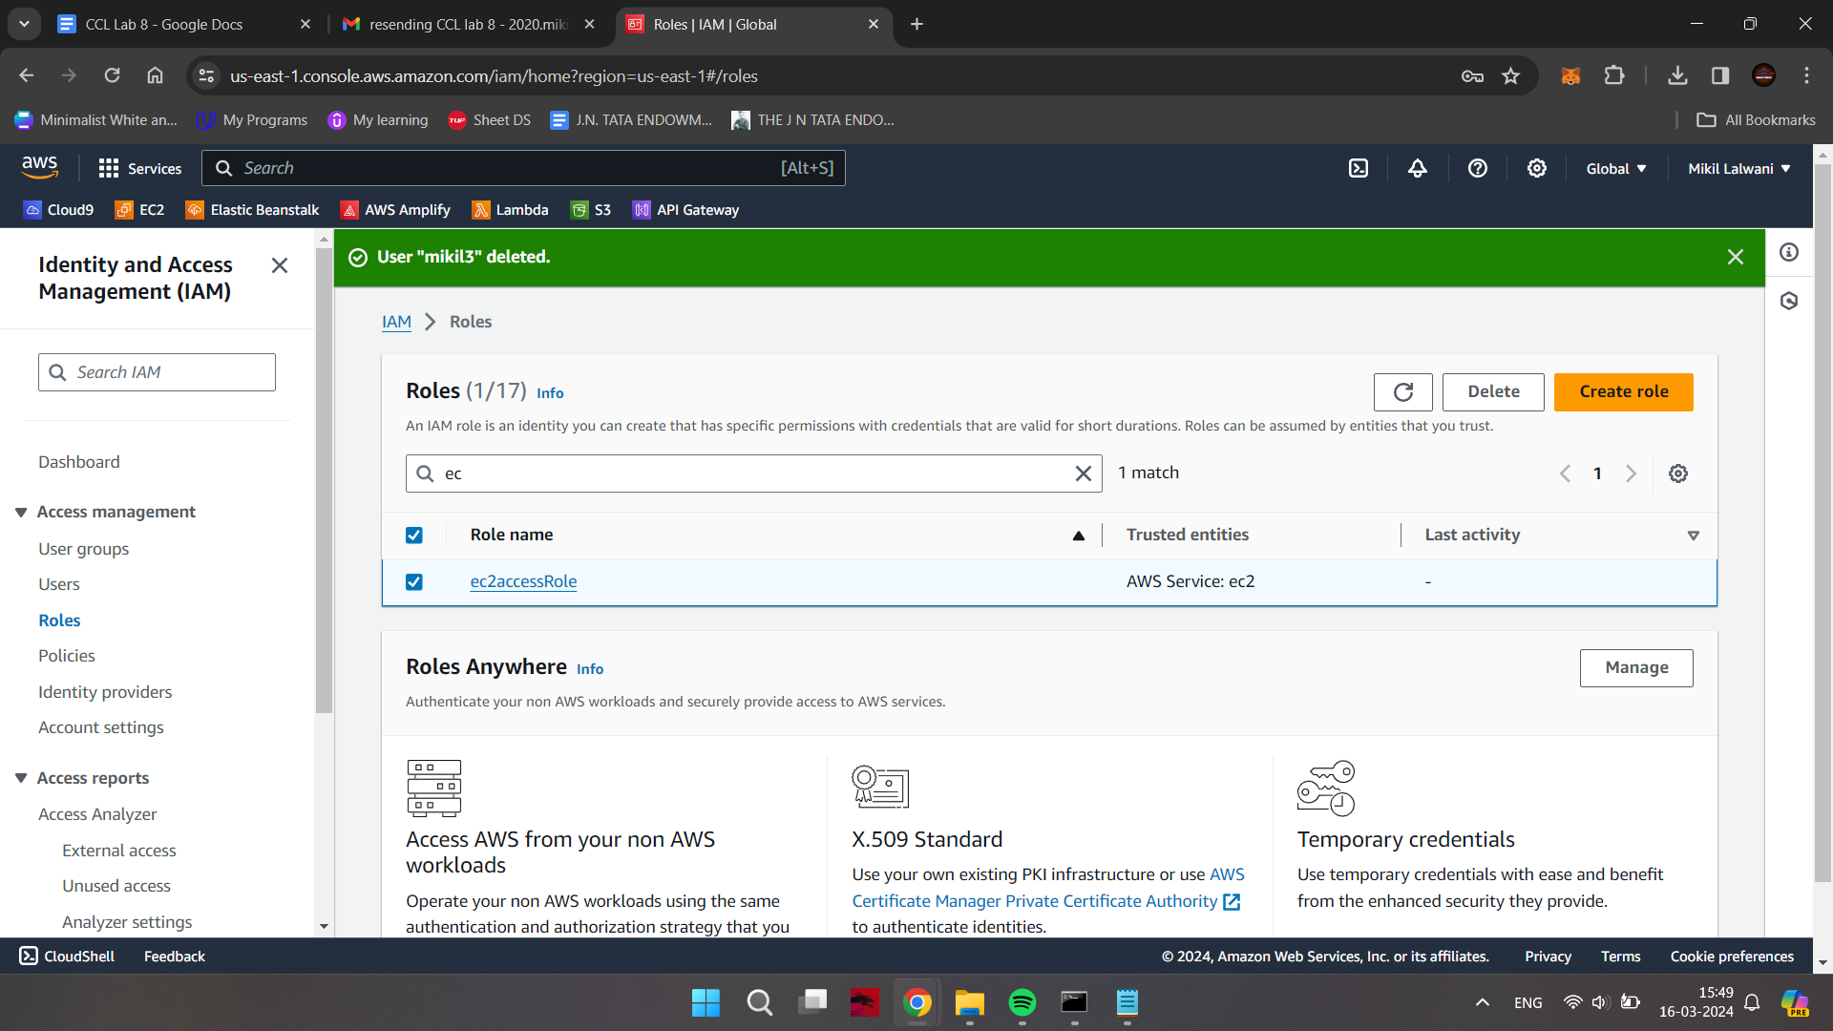

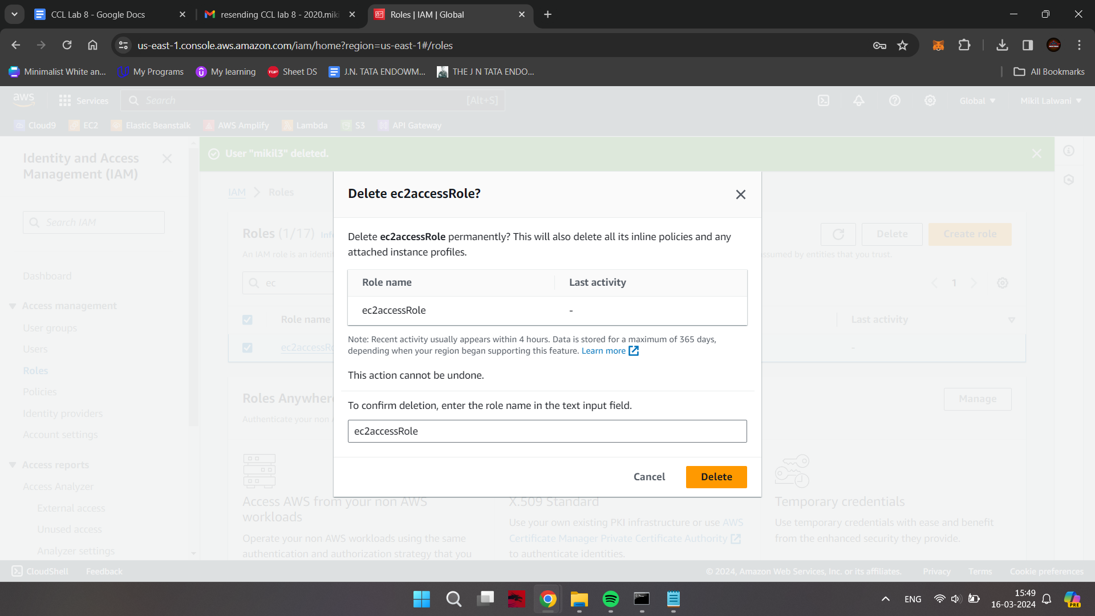

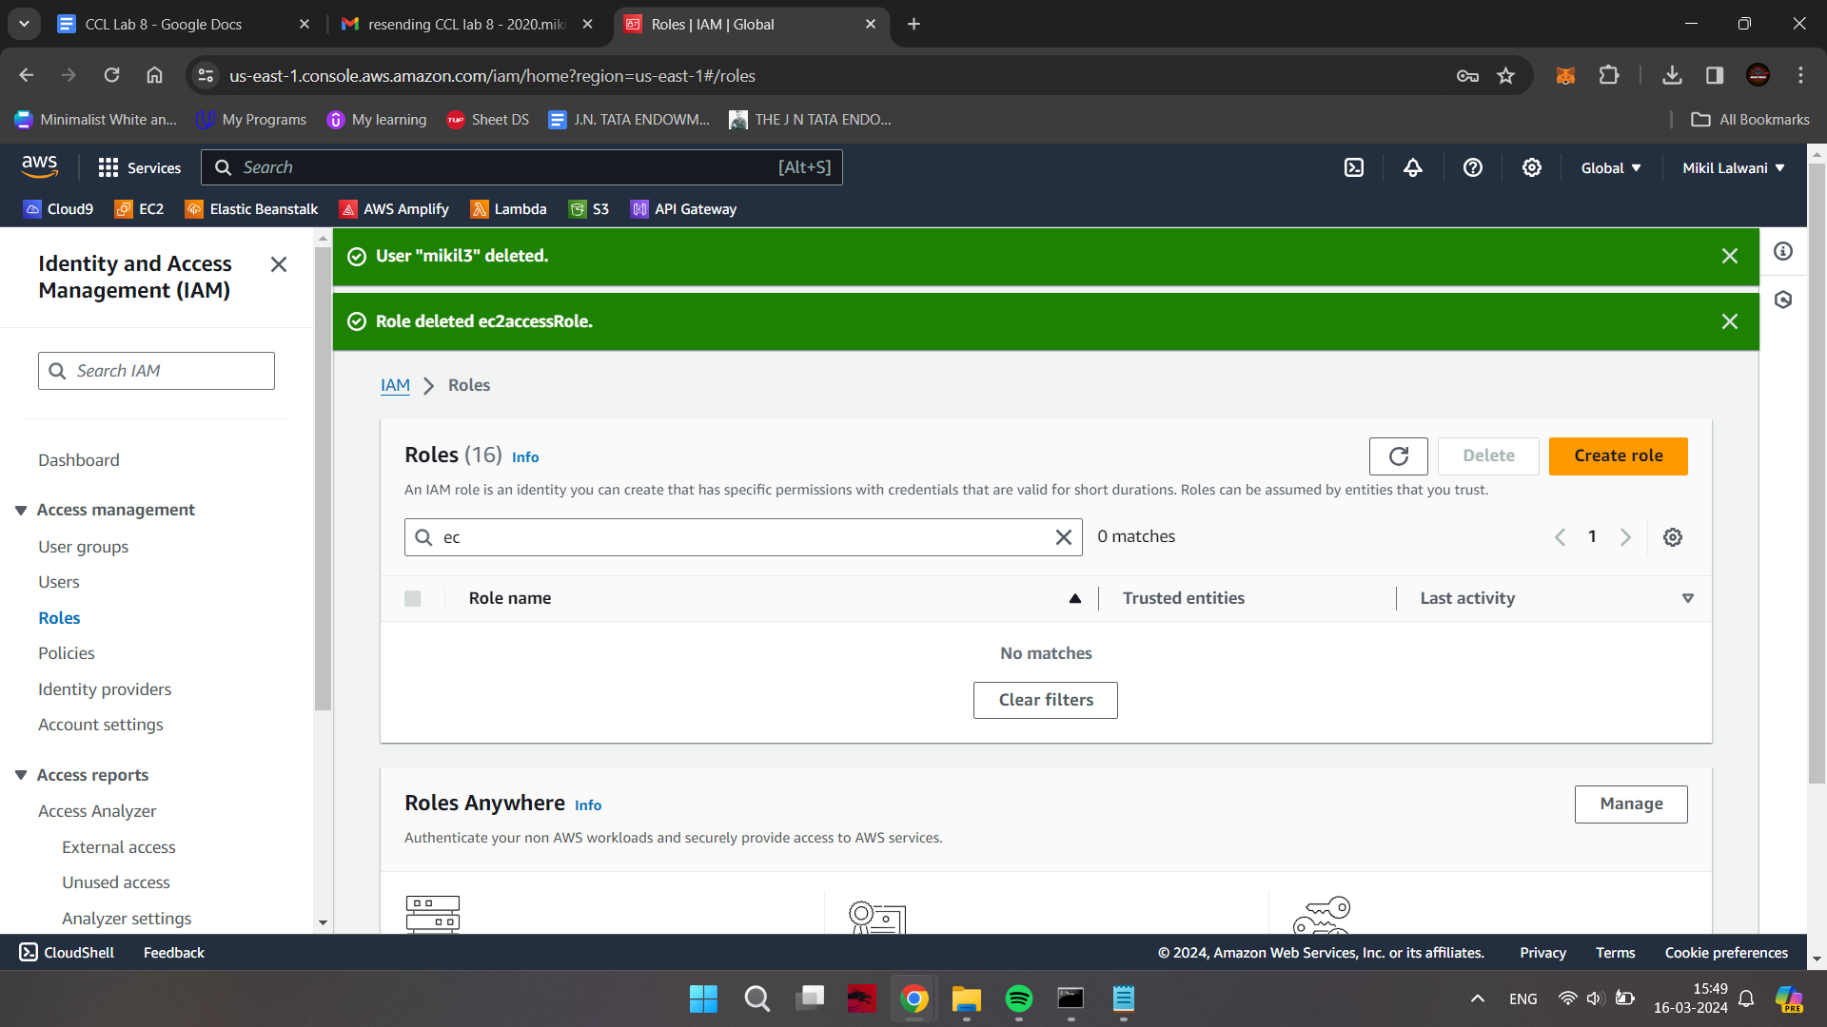

**Deleting a Group**

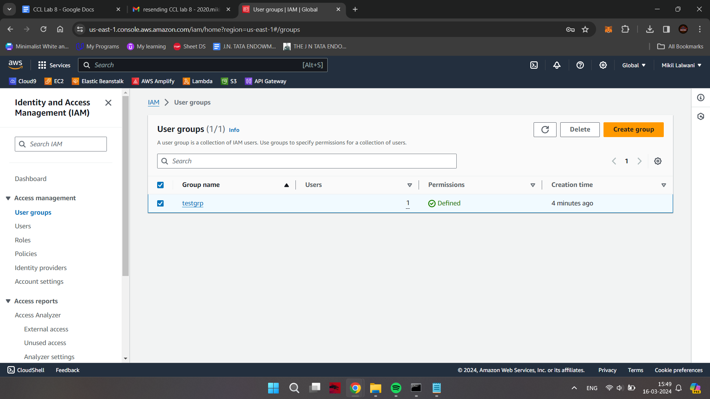

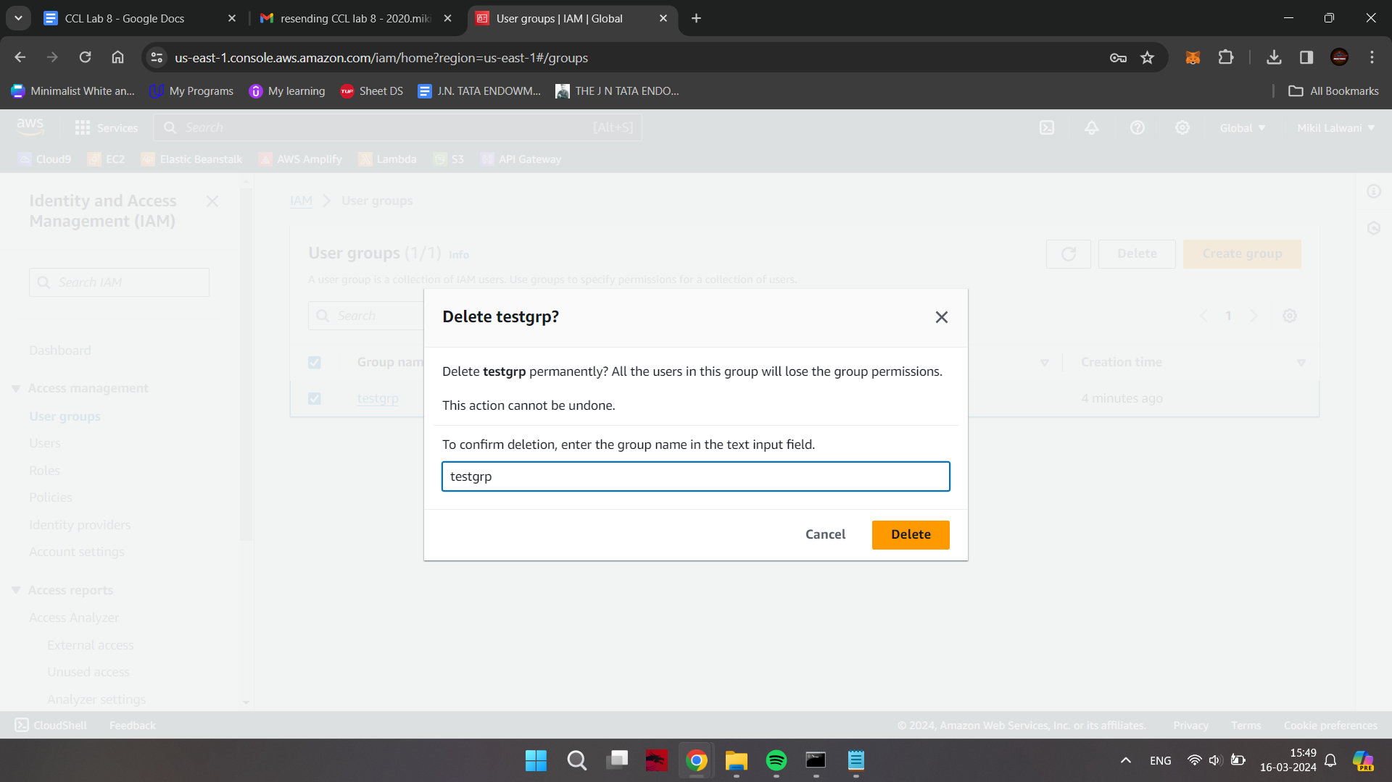

Check the IAM dashboard to see the results after deletion activities

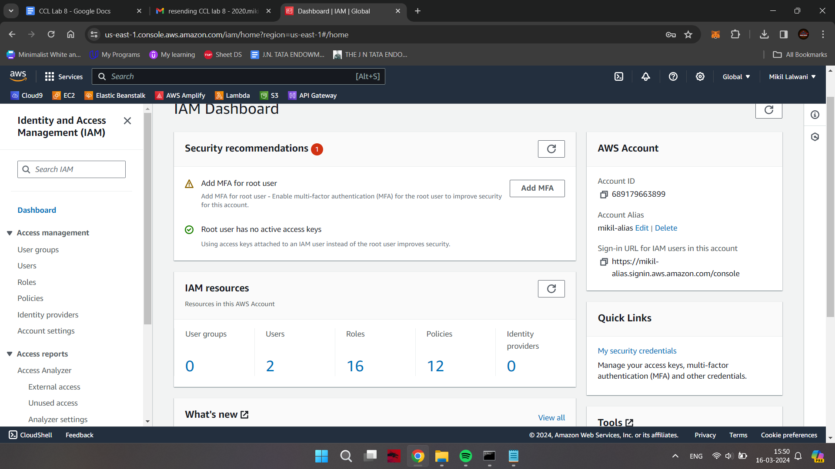

Check the ec2 dashboard in case there are any running instances

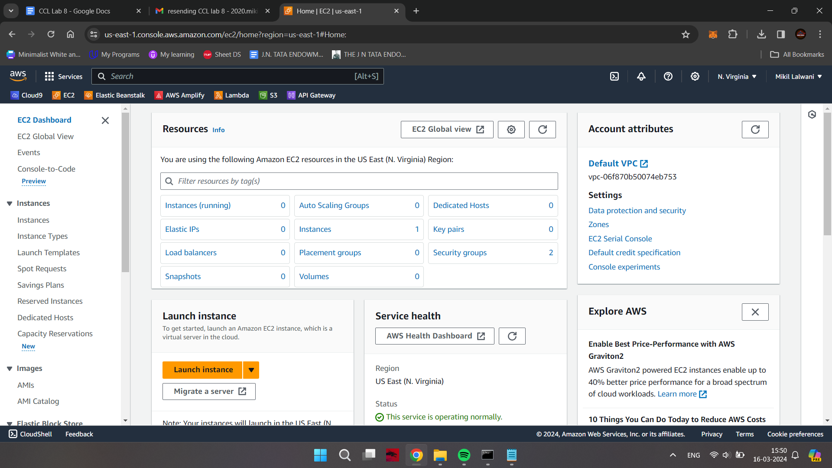

**Conclusion -**

Thus we have successfully studied and implemented Identity and Access Management (IAM) practices on AWS.